This is just one author’s point of view on her Rules to Live By

THE BLOG
06/17/2014 05:57 pm ET Updated Aug 17, 2014

10 Rules to Live By
By Mo Seetubtim
RULE 1: FOLLOW YOUR HEART
Your time is limited, so don’t waste it living someone else’s life. Don’t be trapped by dogma — which is living with the results of other people’s thinking. Don’t let the noise of other’s opinions drown out your own inner voice. And most important, have the courage to follow your heart and intuition. They somehow already know what you truly want to become. Everything else is secondary. — Steve Jobs
If you don’t build your dreams, someone will hire you to help build theirs. — Tony Gaskin
If you do follow your bliss you put yourself on a kind of track that has been there all the while, waiting for you, and the life that you ought to be living is the one you are living. Follow your bliss and don’t be afraid, and doors will open where you didn’t know they were going to be. — Joseph Campbell
—-
RULE 2: DON’T WASTE TIME REGRETTING
Remember that not getting what you want is sometimes a wonderful stroke of luck. — Dalai Lama
I believe that everything happens for a reason. People change so that you can learn to let go, things go wrong so that you appreciate them when they’re right, you believe lies so you eventually learn to trust no one but yourself, and sometimes good things fall apart so better things can fall together. — Marilyn Monroe
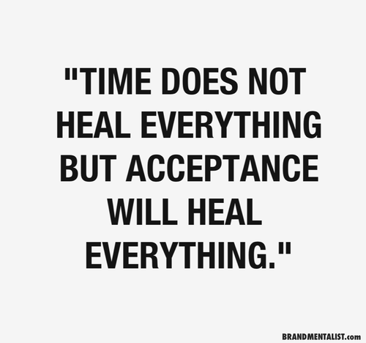
Get the pain and the disappointment out of the way within one day max. Then think about what went wrong, what you did wrong, turn that into a lesson, and move on. Do it better. Make the next one great. Never repeat the same mistake. Accept that you’ve made mistake. Forgive yourself. Don’t waste your time and energy dwelling on things you can’t fix. You can’t turn back time, neither can you extend time in your life. We only have 24 hours in a day, eight hours on sleep. The number of years in your life is not going to increase. It will only decrease if you waste it on a negative energy by being pessimistic, stressed, depressed, and sad. Move on. The sooner you can get back up and be optimistic again, the more you can make efficiency out of time.
Also, sometimes you don’t get something because you’re meant to get something else, something better, something more suitable. Things didn’t work out with your ex whom you loved dearly because you’re meant to be with someone more compatible with you. You didn’t get the job you wanted because you’re destined to get a job somewhere else that is more suitable to your skills and passion. You didn’t get into school X because you’re meant to get into school Y and meet these other amazing people and opportunities.

—-
RULE 3: BELIEVE IN DESTINY
You can’t connect the dots looking forward; you can only connect them looking backwards. So you have to trust that the dots will somehow connect in your future. You have to trust in something — your gut, destiny, life, karma, whatever. This approach has never let me down, and it has made all the difference in my life. — Steve Jobs
You must give up the life you planned in order to have the life that is waiting for you. — Joseph Campbell
The only way to really embrace life is to believe in it. Believe in yourself, your heart, your destiny. Don’t limit your future by limiting yourself to a fixed plan. You never know what will happen. Opportunities might knock on your door. Trust that life will lead you well. Live positively. Follow what feels right. Because when you look back, it will all make sense. If you’re scared you might do something you’ll regret, refer back to Rule 2 — don’t waste time feeling disappointed on something.
RULE 4: BE BOLD AND FEARLESS
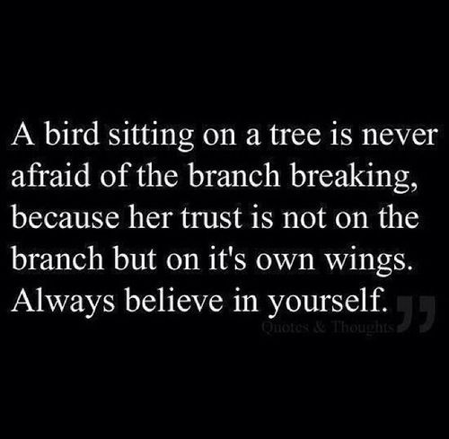
The more you get out of your comfort zone, the easier it gets. When your mind becomes fearless, when you look at competition and challenges as a fun game to tackle, your life changes completely. Nothing is stronger than a person’s mind and willpower. Your mind and your attitudes are the biggest weapons you have and you are in complete control of them.
—-
RULE 5: BELIEVE IN RECIPROCITY
Treat others the way you want to be treated.
There are always times that you don’t want to do something for others because you have to go out of your way, it’s out of your comfort zone, you can’t be bothered. But remember the law of attraction. If you send out positive energy, you will receive the same in return from people. If you go to all of your friends’ birthdays, they will make an effort to come to yours. If you treat others with respect, they will treat you with respect. If you don’t care about others, they won’t care about you. If you take advantage of others, people will run away.
Energy can be felt. It is much more transferable than we might think. Even though some of the negative thinking is in our own head, it comes out. Try to suppress it, you’ll feel suffocated. Try to change your attitudes to be more positive, you will eventually become so. The law of attraction works. And karma, not being superstitious or anything, but it works in the same way of the law of attraction.
Sometimes we have to force ourselves to do things when we don’t feel like — to pick up your best friend’s phone call when you feel like shit, to reply to people’s messages, to make an effort to attend people’s farewell parties, to say hi and be friendly to work colleagues and the baristas at your local cafe, to ask for permission from your friend before using their stuff at their house, to make your friend’s place tidy even though you were told to make yourself at home, and to not be pessimistic and whine all the time. Because this is how you are going to be treated. If you treat others right, you will be treated right. And for those who don’t treat you right, remember they are not worth your time.
RULE 6: BLOOD IS THICKER THAN WATER
Other things may change us, but we start and end with family.
No matter what happens in life, family is always there. When we’re young, friends come first, other things come first. But no matter what happens in life, family is always there. Not always the case for everyone, but for most of us, remember, that when you’re sick, when you’re broke to the point that you can’t afford any food or shelter, you always have family. Never ever forget where you’re from and who you are. Never let the burden of the upbringing become your weakness. Embrace it because even the tough upbringing makes you who you are, makes you stronger, and shapes your attitudes towards life. Don’t forget to tell your parents you love them. They aren’t going to be with you forever.
RULE 7: CHANGE IS CERTAIN 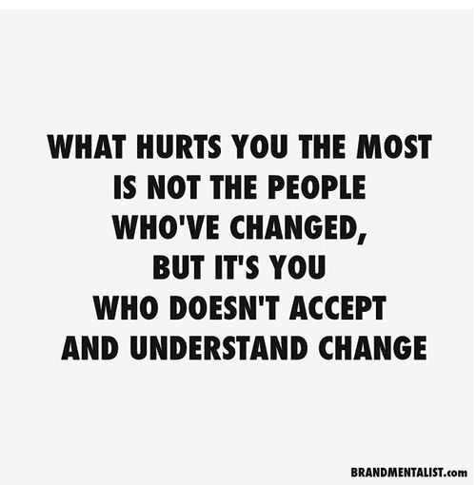

This is one of my favourite Buddhism quotes.
Embrace change. It’s a part of life. By being rigid and resisting to change, you’re hurting yourself. Live life with an open mind and open arms. One little event in one’s life can totally change their whole life plan. Plan as a springboard to wide imagination. Don’t be mad if plans change. The less stigma you have in life, the more free you feel spiritually, the happier you feel.
—-
RULE 8: NEVER HOLD BACK YOUR FEELINGS
Should’ve, Could’ve, Would’ve...
You never know unless you try. We regret things we didn’t do more than the things we did. You’ve got nothing to lose. Don’t be afraid of rejection. It’s better to be rejected and move on than wondering “what if” because What If’s could haunt you for the rest of your life.
Trust your instinct. Trust your heart. If something is meant to be, it will work out. If not, then it’s better to know and move on. When you present life with honesty, life responds back to you honestly.
—-
RULE 9: ALWAYS SHOW APPRECIATION TO THOSE WHO DESERVE IT
A human’s deepest, most sensitive desire is to feel appreciated. It’s what makes us feel alive. It’s what gives us, our lives, meaning. When you show others how appreciative you are of their work or what they’ve done for you, it makes them feel valued and meaningful. It affects one’s self-esteem and self-worth. Naturally, we want to do something that increases our self-esteem and our self-worth. When you show appreciation, the person will be even more likely to help you and do great work for you because when they feel appreciated, they feel good. And who doesn’t want to feel good? It’s how we are after all.

—-
RULE 10: LOVE YOURSELF
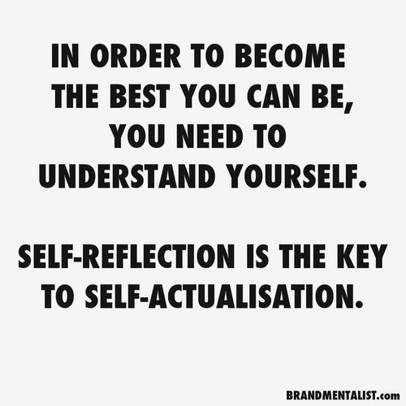
The more you understand yourself, the more in touch you are with yourself, the happier you become. Just like any business strategy, the better you understand the root of the business problem, the more likely you are able to solve it. That’s why self-reflection is so important. It leads to understanding yourself, life, and people around you. Self-reflection helps you understand why you are the way you are, why you like/dislike something, what causes you to feel unhappy, and what you can do to become a better, happier person.
When you start doing self-reflection on a regular basis, you will start to notice how happier you become — on your own. You won’t need someone or something to complete you. You will feel complete within you. And that is much more sustainable in the long run. Because no matter what happens, years to come, you are going to be with yourself. Nothing ain’t going to be with you forever but yourself.

