Grade 5: Module 1: Unit 3: Lesson 4
Mid-Unit Assessment: Evaluating a Novel Versus a Script

Long-Term Targets Addressed (Based on NYSP12 ELA CCLS)
I can explain what a text says using quotes from the text. (RL.5.1)
I can make inferences using quotes from text. (RL.5.1)
I can determine the meaning of literal and figurative language (metaphors and similes) in text. (RL.5.4)
I can explain how a series of chapters, scenes or stanzas fit together to create a larger literary text. (RL.5.5)
I can describe how a narrator’s point of view influences the description of events. (RL.5.6)
I can compare and contrast stories in the same genre for approach to theme and topic. (RL.5.9)
Supporting Learning Targets | Ongoing Assessment
- I can describe the similarities and differences between a novel and a script.  - I can describe the connections between the UDHR and a script or a novel.  - I can describe the author’s motivations for creating a script.  - I can describe the role of a narrator in a script.  - I can share my opinions about a novel and a script. | - Mid-Unit Assessment: Evaluating a Novel versus a Script  - Self-assessment

Agenda | Teaching Notes
- Opening  - Reviewing Learning Targets (5 minutes)  - Academic Vocabulary Clarification (10 minutes)  - Work Time  - Mid-Unit Assessment (40 minutes)  - Closing and Assessment  - Self-Assessment (5 minutes)  - Homework | - In advance: Make student notes and anchor charts from Lessons 1–3 available for student reference during the assessment.

Lesson Vocabulary | Materials
evaluate, Venn diagram, compare, contrast, script, novel, narrator, cite with evidence, introduce, passages, scene, effective | - Mid-Unit Assessment: Evaluating a Novel versus a Script (one per student)  - Mid-Unit Assessment: Evaluating a Novel versus a Script (Sample Responses for Teacher Reference)  - Relevant notes and anchor charts from Lessons 1–3 (for student reference during the assessment)

Opening | Meeting Students’ Needs
A. Reviewing Learning Targets (5 minutes)  - Read the learning targets aloud and ask students to restate them in their own words. Clarify as needed. | - All students developing academic language will benefit from direct instruction of academic vocabulary.
B. Academic Vocabulary Clarification (10 minutes)  - Make sure students understand that to evaluate means to examine something more closely to judge it: to think about its strengths and weaknesses. Point out that many students know this word from school in reference to how strong their work is or what they need to improve.  - Ask students to turn and talk about times they have been “evaluated” or have gotten to evaluate something. Listen for students to make connections to being evaluated in school, at the doctor, etc. Students also may offer examples of times they have evaluated, or judged, something else: a movie, etc. Clarify misconceptions about this key vocabulary term.  - Tell students that today, they will be evaluating two types of narrative writing: a novel and a script.  - Tell them that often when you evaluate something, you are comparing it to something else. For example, if you say that a movie is great, this is compared to another movie you didn’t like as much. Tell students that today, they will first think about how novels and scripts are alike and different. They will complete a Venn diagram, which is a graphic organizer used to help compare (identify similarities) and contrast (identify differences) a novel and a script. Remind students that they have been working with “scripts” while participating in Readers Theater during Lessons 1 and 2; they also had an opportunity to discuss and critique the role of narrator in both Readers Theater scripts in Lesson 3. | - Some students may be unfamiliar with academic vocabulary words. Clarify vocabulary with students as needed.

Opening (continued) | Meeting Students’ Needs
- Tell students: “Today you are going to complete a Mid-Unit 3 Assessment in which you will complete a Venn diagram comparing and contrasting scripts and a novel. Then you will read selected passages from the novel Esperanza Rising and the script based on the same novel, in order to respond to some short-answer questions. It will be important for you to support your answers by citing evidence from both the novel and the script.” Clarify terms further, as necessary.
- Ask students to turn and talk to check their understanding of compare, contrast, and evaluate. What thinking will they need to do on the Mid-Unit 3 Assessment?

Work Time | Meeting Students’ Needs
A. Mid-Unit Assessment: Evaluating a Novel versus a Script (40 minutes)  - Distribute the Mid-Unit Assessment: Evaluating a Novel versus a Script, to each student (see supporting materials).  - Address clarifying questions then invite students to begin. | - Visuals can help students comprehend questions.  - For ELLs, consider providing extra time for tasks and answering questions in class discussions. ELLs often need more time to process and translate information. ELLs receive extended time as an accommodation on NY State assessments.

Closing and Assessment | Meeting Students’ Needs
A. Self-Assessment (5 minutes)  - Reorient students to the learning targets. Ask the class to show a thumbs-up, -sideways, or -down to signal how well they feel they did meeting these targets.  - Ask students to think, then turn and talk with a partner:  - “What is something you did well on the mid-unit assessment? Be specific.”  - “What is something that was hard for you? Be specific.”  - Point out to students that what they are doing right now is evaluating themselves: thinking about their strengths and weaknesses. | - For students needing additional supports, consider offering a sentence frame or starter, or a cloze sentence to assist with language production and provide the structure required.
Homework | Meeting Students’ Needs
- None

Grade 5: Module 1: Unit 3: Lesson 4
Supporting Materials

- Compare (similarities) and contrast (differences) a script a novel by completing the Venn diagram below.
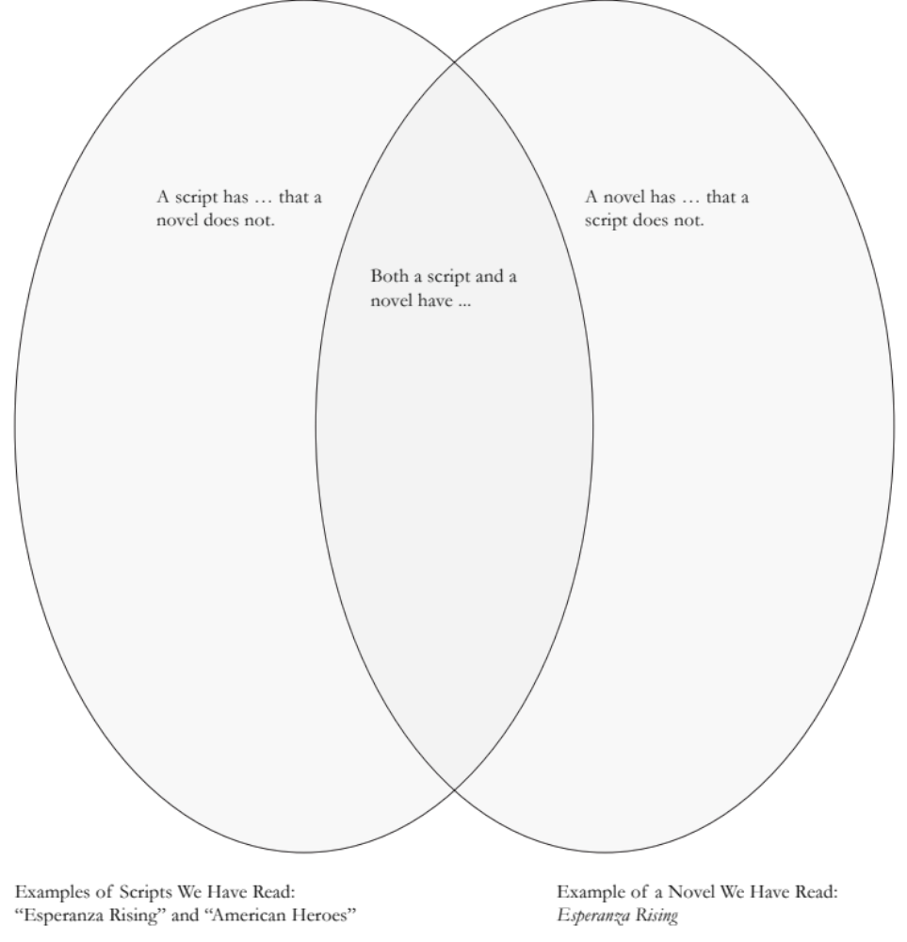

2. Read both passages below. Passage A is from the novel Esperanza Rising. Passage B is from Pam Muñoz Ryan’s Readers Theater script. Answer the questions that follow, making sure to cite evidence for your answers using the text provided.

Passage A: From Esperanza Rising, the novel (pp. 28–30)

Tío Luis and Tío Marco came every day and went into Papa’s study to “take care of the family business.” At first, they stayed only a few hours, but soon they became like la calabaza, the squash plant in Alfonso’s garden, whose giant leaves spread out, encroaching upon anything smaller. The uncles eventually stayed each day until dark, taking all their meals at the ranch as well. Esperanza could tell that Mama was uneasy with their constant presence.
A little too loudly, Tío Luis said, “Ramona, grieving does not suit you. I hope you will not wear black all year!”
Mama did not answer but maintained her composure.
“Ramona,” said the lawyer. “Your husband, Sixto Ortega, left this house and all of its contents to you and your daughter. You will also receive the yearly income from the grapes. As you know, it is not customary to leave land to women and since Luis was the banker on the loan, Sixto left the land to him.”

Passage B: From “Esperanza Rising” the script (pp. 4–5)

NARRATOR: But soon they became like las calabaza, the squash plant in the garden, whose giant leaves encroached upon anything smaller.

ESPERANZA: Eventually, the uncles stayed all day, even taking their meals at the ranch. And Mama was uneasy with their presence.

MIGUEL: Finally, the lawyer came to settle the estate. As the uncles walked into the study, Mama and Esperanza sat properly in their black dresses.

TIO LUIS: Ramona! Grieving does not suit you. I hope you will not wear black all year!

ESPERANZA: Mama did not answer him. Instead she maintained her composure and looked at the lawyer.

LAWYER: Ramona, your husband, Sixto Ortega, left this house and all of its contents to you and your daughter. You will also receive the yearly income form the grapes. As you know, it is not customary to leave land to women and since Luis is his brother, Sixto left the land to him.

- How are the passages from the novel similar to the passages from the script? Support your answer with evidence from both texts.

- How are the passages from the novel different from the passages of the script? Support your answer with evidence from both texts.

- How do both the novel and the script connect to the UDHR? Support your answer with evidence from all three texts.

- The narrator introduces the scene in the script with the line, “But soon they became like la calabaza, the squash plant in the garden, whose giant leaves encroached upon anything smaller.”

Based on the context, what do you think the word encroached means?

Why do you think Pam Muñoz Ryan chose to begin the scene with this passage? Consider how this line of narration relates to the rest of the script. Support your answer with evidence.

- We will be writing Readers Theater scripts of our own and need to think about how to engage our audience. How did Pam Muñoz Ryan use the role of NARRATOR in her Readers Theater script to help engage the audience with her story? Cite examples from the script.

  - Compare (similarities) and contrast (differences) a script a novel by completing the Venn diagram below.

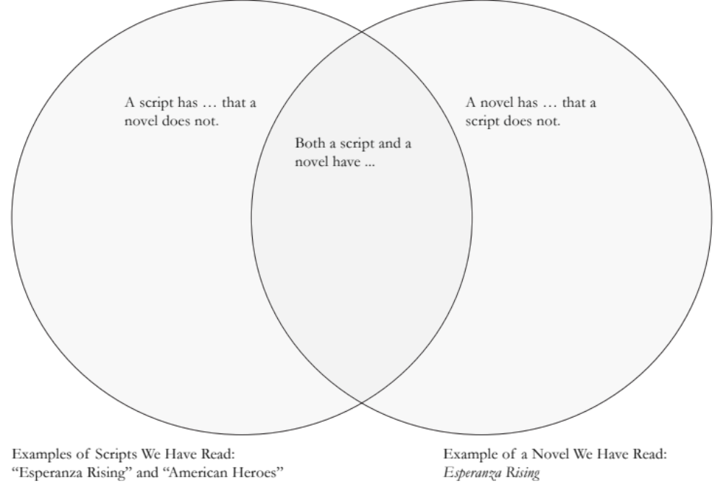

Both a novel and a script have:
- The same characters in the scene
- Some of the same dialogue
- Some of the same actions by characters
- The same events.

A script has that a novel does not:
- A narrator who is different to the characters in the scene.
- More dialogue – a script tells the same story through dialogue and actions.

A novel has that a script does not:
- Descriptions and details about an event.
- Descriptions of thoughts and feelings.

  - Read both passages below. Passage A is from the novel Esperanza Rising. Passage B is from Pam Muñoz Ryan’s Readers Theater script. Answer the questions that follow, making sure to cite evidence for your answers using the text provided.

Passage A: From Esperanza Rising, the novel (pp. 28–30)

Tío Luis and Tío Marco came every day and went into Papa’s study to “take care of the family business.” At first, they stayed only a few hours, but soon they became like la calabaza, the squash plant in Alfonso’s garden, whose giant leaves spread out, encroaching upon anything smaller. The uncles eventually stayed each day until dark, taking all their meals at the ranch as well. Esperanza could tell that Mama was uneasy with their constant presence.
A little too loudly, Tío Luis said, “Ramona, grieving does not suit you. I hope you will not wear black all year!”
Mama did not answer but maintained her composure.
“Ramona,” said the lawyer. “Your husband, Sixto Ortega, left this house and all of its contents to you and your daughter. You will also receive the yearly income from the grapes. As you know, it is not customary to leave land to women and since Luis was the banker on the loan, Sixto left the land to him.”

Passage B: From “Esperanza Rising” the script (pp. 4–5)

NARRATOR: But soon they became like las calabaza, the squash plant in the garden, whose giant leaves encroached upon anything smaller.

ESPERANZA: Eventually, the uncles stayed all day, even taking their meals at the ranch. And Mama was uneasy with their presence.

MIGUEL: Finally, the lawyer came to settle the estate. As the uncles walked into the study, Mama and Esperanza sat properly in their black dresses.

TIO LUIS: Ramona! Grieving does not suit you. I hope you will not wear black all year!

ESPERANZA: Mama did not answer him. Instead she maintained her composure and looked at the lawyer.

LAWYER: Ramona, your husband, Sixto Ortega, left this house and all of its contents to you and your daughter. You will also receive the yearly income form the grapes. As you know, it is not customary to leave land to women and since Luis is his brother, Sixto left the land to him.

- How are the passages from the novel similar to the passages from the script? Support your answer with evidence from both texts.

- The first line the narrator says in the script is very similar to a line in the novel. In the script the narrator says, “But soon they became like las Calabasas, the squash plant in the garden, whose giant leaves encroached upon anything smaller.” In the novel it says, “soon they became like la calabaza, the squash plant in Alfonso’s garden, whose giant leaves spread out, encroaching upon anything smaller.”
- Some of the same dialogue is evident. For example in both Tio Luis says, “Ramona! Grieving does not suit you. I hope you will not wear black all year!”
- In both the lawyer comes to settle the estate and the dialogue from the novel is used in the script. In both the lawyer says, “Ramona, your husband, Sixto Ortega, left this house and all of its contents to you and your daughter. You will also receive the yearly income form the grapes. As you know, it is not customary to leave land to women and since Luis is his brother, Sixto left the land to him.”

- How are the passages from the novel different from the passages of the script? Support your answer with evidence from both texts.

- Miguel has a line in the script, but is not evident in the novel. In the script Miguel says, “Finally, the lawyer came to settle the estate. As the uncles walked into the study, Mama and Esperanza sat properly in their black dresses.”
- Esperanza plays the part of the narrator in the script when she says, “Mama did not answer him. Instead she maintained her composure and looked at the lawyer.”

- How do both the novel and the script connect to the UDHR? Support your answer with evidence from all three texts.
- In article 12 of the UDHR it says, “No one shall be subjected to arbitrary interference with his privacy, family, home or correspondence, nor to attacks upon his honour and reputation.” In the script and in the novel the uncles are interfering in the privacy, family and home of mama, Esperanza and Miguel. In the script the narrator says, “But soon they became like las Calabasas, the squash plant in the garden, whose giant leaves encroached upon anything smaller.”

- The narrator introduces the scene in the script with the line, “But soon they became like la calabaza, the squash plant in the garden, whose giant leaves encroached upon anything smaller.”

- Based on the context, what do you think the word encroached means?
- Grew so big that they spread into the path of anything smaller.
- Why do you think Pam Muñoz Ryan chose to begin the scene with this passage? Consider how this line of narration relates to the rest of the script. Support your answer with evidence.
- Because she is setting the scene that the uncles, the big men, were trying to taking over and control Esperanza, Miguel and their mama. The ‘anything smaller’ that are Esperanza, Miguel and their mama.

e. We will be writing Readers Theater scripts of our own and need to think about how to engage our audience. How did Pam Muñoz Ryan use the role of NARRATOR in her Readers Theater script to help engage the audience with her story? Cite examples from the script.

- She uses the narrator at the very beginning to set the scene for what the uncles are doing, so that we understand what is going on. The narrator says, “But soon they became like las Calabasas, the squash plant in the garden, whose giant leaves encroached upon anything smaller.”

