New York State Common Core

English Language Arts
Curriculum

GRADE 6 Module 1
Unit 3
Student Workbook

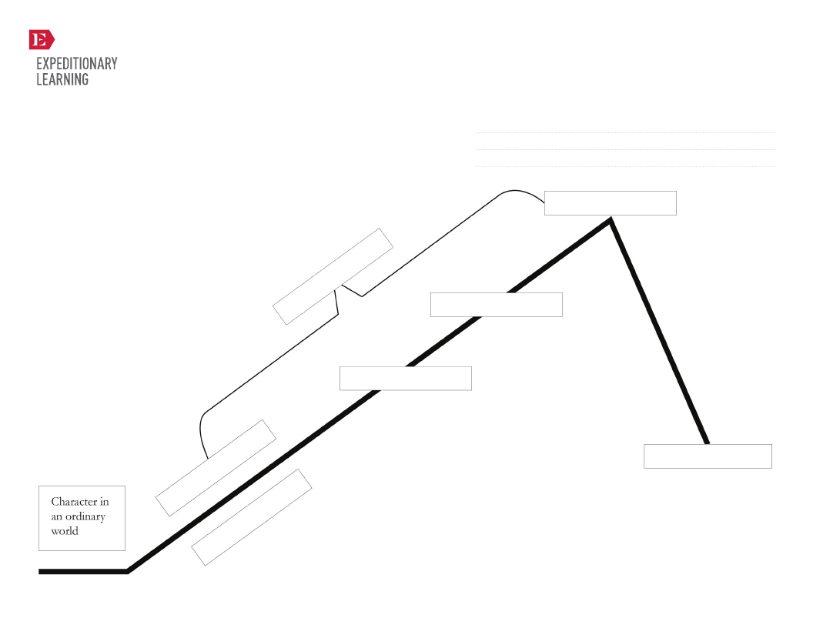

Created by Expeditionary Learning, on behalf of Public Consulting Group, Inc.
© Public Consulting Group, Inc., with a perpetual license granted to
Expeditionary Learning Outward Bound, Inc.

1

GRADE 6: MODULE 1: UNIT 3: LESSON 1
Narrative Story Line—
“Hero’s Journey”

Name:
Date:

NYS Common Core ELA Curriculum • G6:M1:U3:L1 • June 2013 • 1

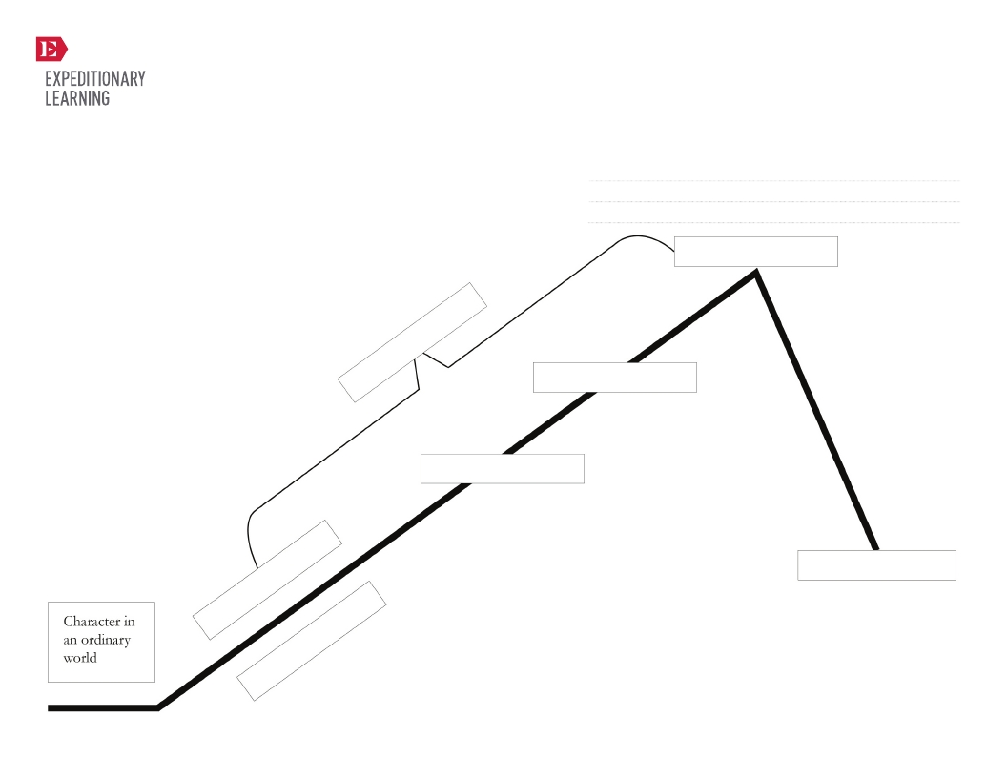

Created by Expeditionary Learning, on behalf of Public Consulting Group, Inc.
© Public Consulting Group, Inc., with a perpetual license granted to
Expeditionary Learning Outward Bound, Inc.

2

GRADE 6: MODULE 1: UNIT 3: LESSON 1
Narrative Story Line—
“Hero’s Journey”

Name:
Date:

NYS Common Core ELA Curriculum • G6:M1:U3:L1 • June 2013 • 2

Character Name:

Nick name:

Age:

Hair Color and Style:

Body Type:
(height/weight)

Clothing
“Style”:

Race/Ethnicity:

B

G

GRADE 6: MODULE 1: UNIT 2: LESSON 1
Differentiated Exit Ticket Scaffold

Scars or other
distinguishing
marks:

Hopes:

Fears:

Created by Expeditionary Learning, on behalf of Public Consulting Group, Inc.
© Public Consulting Group, Inc., with a perpetual license granted to
Expeditionary Learning Outward Bound, Inc.

3

NYS Common Core ELA Curriculum • G6:M1:U3:L6 • June 2013 • 3

GRADE 6: MODULE 1: UNIT 3: LESSON 2
Hero’s Journey Narrative:
Plan Graphic Organizer

A long time ago, there was a hamlet, and in this small village there lived a farm girl named Marney. Marney’s parents died when
she was very young. She lived on a farm at the bottom of a large mountain with her loving grandparents. Marney’s grandparents
once had a fertile farm filled with an abundance of vegetables and fruits that her grandfather would take to the market to sell.
The farm was rich with trees, birds, and animals of every species that made their homes on the farm. There was plenty for all,
and all were happy.
But now things were different. Spring never arrived. The soil had become hard, and the seeds could not be planted. Food was
scarce, so the animals that had once inhabited the land left to seek more bountiful homes, plentiful with food and shelter.
Marney’s grandparents were woeful, worried that they, too, would have to leave their home.
One evening, after a dinner of broth so meager, it ran from the spoon like water, Marney’s grandfather, sat beside her at the fire.
“Marney, you are a perceptive and sensitive child. As you know, things are not going well for us on the farm this year. Marney,
you are the only person that can save the farm from demise.”

“Tell me more, Grandpa,” Marney said.

“When you were born, Lord Dismalt put an evil spell on our farm. He said that in the year that you turned ten, our beauteous and
fertile farm would become barren, the trees would not bear fruit and the land would become so tough that no seeds would be
planted. Soon the farm and all of us would perish. He told us that you were the only one who could save us and that you would
have to travel up the forbidden mountain and overcome many obstacles in order to reach the golden key that would unlock the
curse and redeem our land.”
That night, Marney couldn’t sleep. She put on her clothes and quietly crept out of the kitchen door into the dark night. She was
frightened, but she couldn’t let that stop her.
She walked faster and faster until she reached the foot of the mountain, which was surrounded by a forest. The trees were so
thick that it was impossible to find a path through the forest. Suddenly, a white goat appeared.
“Hello, goat. I am trying to find my way through this murky forest, dark and dense, so that I can save my family’s farm, but I
cannot find a path on which to walk. Do you think that you could help me, please?”
“Follow me,” said the white goat.
Marney followed the goat as he munched a path for her through the forest. At the end of the forest, he turned to Marney and said,
“I can go no farther. Good luck on your journey, my friend.” With that, the white goat vanished.
Marney began the steep climb up the incline of the dark mountain. Suddenly, it began to rain. The mountainside was slick, and
Marney kept slipping and skidding into the mud. She began to weep, “Please, please can someone help me! I must make this trek
to the dark castle to save my family’s farm.”
There before her appeared a giant white eagle. The bird spread its colossal wings, swooped down from the sky, picked Marney up,
and flew her to the top of the mountain.
“Thank you for your help, eagle. Now I must find the golden key,” Marney said.
“Good luck on your journey,” the eagle replied. “The obstacles that you have faced are nothing like the one that lies ahead of
you.” With that, the eagle flew away.

“Clang … clang … clang, clang,” something hard fell from the sky. It hit the side of the building and the roof of the entryway
before landing at Marney’s feet. “You’re going to need this,” the eagle shouted from the blackened branch of a tree. Marney
picked up the sword.
She walked toward the door of the castle and opened it ever so slowly. A cold breeze enveloped her. She walked down a dark
hallway to the right, then turned a gloomy corner. There she saw him, the evil Lord Dismalt slobbering over a roasted vulture leg.

Created by Expeditionary Learning, on behalf of Public Consulting Group, Inc.
© Public Consulting Group, Inc., with a perpetual license granted to

Expeditionary Learning Outward Bound, Inc.

4
NYS Common Core ELA Curriculum • G6:M1:U2:L2 • June 2013 • 1

“Ho, there!” Marney called.
“What, is someone here?”

GRADE 6: MODULE 1: UNIT 3: LESSON 2
Hero’s Journey Narrative:
Plan Graphic Organizer

“Yes. It is I, Marney. When I was born, you put an evil curse on my family. I have come to get the magic key that will restore my
family’s farm to what it once was.”
“I have no key, child.”
“You are a liar. It is there on the chain around your neck!”
“You will have to take this key from me. I will never give it up.”
Marney moved in closer. She pointed her sword at the evil Lord Dismalt. “Give me the key. Give me the key or we will fight to the
death.”
At that, Lord Dismalt pulled his sword from its sheath and lunged toward Marney with all of his might. When he stood up,
Marney realized that Lord Dismalt was only four feet tall. He had really skinny legs, so Marney decided to strike there first. She
gave him one big kick to the shins, and Lord Dismalt fell on his knees crying. She zoomed in and stuck her sword in his face.
“Give me the key, Dismalt, or face your death!”
“Oh, all right!” Dismalt yanked the key from around his neck and tossed it over to Marney. As he placed the key in Marney’s hand,
he transformed into a radiant white pony.
Marney climbed upon his back and rode him safely back to her grandparents’ farm.
When they saw her, Marney’s grandparents were overjoyed. Marney dismounted and noticed that her grandfather was carrying a
box. “What’s that?” Marney asked.
“This is your last challenge, Marney. The key will unlock this box.”
Marney put the key in the box and turned it to the right. The box popped open, and from it flowed the spring.
At that moment, the flowers bloomed. The soil became rich and fertile. Marney could hear the birds in the sky and the animals
returning to their homes. Marty had saved spring and restored her family farm! And as for Lord Dismalt … well, he lives happily
in the paddock, munching grass and basking in the light of day!

Created by Expeditionary Learning, on behalf of Public Consulting Group, Inc.
© Public Consulting Group, Inc., with a perpetual license granted to

Expeditionary Learning Outward Bound, Inc.

5
NYS Common Core ELA Curriculum • G6:M1:U2:L2 • June 2013 • 2

Stage of “The Hero’s
Journey”

The Ordinary World

How do we meet your
hero?
Where does your hero’s
journey begin?

The Call to Adventure

What happens to set your
hero on his or her
journey?

Entering the Unknown

What is the new world
your hero enters?

My Hero’s Journey
(Sequence of Events)

GRADE 6: MODULE 1: UNIT 3: LESSON 2
Hero’s Journey Narrative:
Plan Graphic Organizer

Name:
Date:

Writer’s Craft Ideas
(Style and Craft)

Created by Expeditionary Learning, on behalf of Public
Consulting Group, Inc.
© Public Consulting Group, Inc., with a perpetual license
granted to
Expeditionary Learning Outward Bound, Inc.

6

NYS Common Core ELA Curriculum • G6:M1:U3:L2 • June 2013 • 3

Stage of “The Hero’s
Journey”

Supernatural Aid/Meeting
with the Mentor/Allies and
Helpers

Who is going to help your
hero on the journey?

How does your hero meet
these helpers?

Road of Trials

What are some obstacles
your hero and allies must
overcome?

Supreme Ordeal

What is the climax of your
hero’s journey?

Magic/Flight
Master of Two
Worlds/Restoring the
World

How does your hero get
home?
What happens once the
hero is home?

My Hero’s Journey
(Sequence of Events)

GRADE 6: MODULE 1: UNIT 3: LESSON 2
Hero’s Journey Narrative:
Plan Graphic Organizer

Writer’s Craft Ideas
(Style and Craft)

Created by Expeditionary Learning, on behalf of Public
Consulting Group, Inc.
© Public Consulting Group, Inc., with a perpetual license
granted to
Expeditionary Learning Outward Bound, Inc.

7

NYS Common Core ELA Curriculum • G6:M1:U3:L2 • June 2013 • 4

I’ve thought about and planned for:

GRADE 6: MODULE 1: UNIT 2: LESSON 2
Thinking about Elements of Story
and Theme Checklist

Name:
Date:

My hero – Who is your hero? How do readers meet the hero?

The Ordinary World – What is the setting at the beginning?

The Call to Adventure – How is your hero started on his or her journey?

The Supernatural World – What kind of place is the new world going to be?

The Allies – Who will be helping your hero along the way?

The Road of Trials – What obstacles is your hero going to encounter?

The Supreme Ordeal – What is going to be the climax of your story?

The Return – How is your hero going to get home? What happens once he or she is home?

Theme – What is the big idea or lesson of your story? (Remember to look at “Key Elements of Mythology” to help you
remember some of the themes we have learned about.)

Created by Expeditionary Learning, on behalf of Public
Consulting Group, Inc.
© Public Consulting Group, Inc., with a perpetual license
granted to

Expeditionary Learning Outward Bound, Inc.

8
NYS Common Core ELA Curriculum • G6:M1:U3:L2 • June 2013 • 5

GRADE 6: MODULE 1: UNIT 3: LESSON 3
Mid-Unit 3 Assessment: Crosswalk between
My Hero’s Journey Narrative and “The Hero’s Journey”
Informational Text

Name:
Date:

How does your plan for a hero’s journey align with the archetype of “The Hero’s Journey?”

Write a paragraph describing two ways in which in which your plan for a narrative aligns with the archetype of “The Hero’s
Journey.”

Created by Expeditionary Learning, on behalf of Public Consulting Group, Inc.
© Public Consulting Group, Inc., with a perpetual license granted to

Expeditionary Learning Outward Bound, Inc.

9
NYS Common Core ELA Curriculum • G6:M1:U2:L3 • June 2013 • 1

GRADE 6: MODULE 1: UNIT 3: LESSON 5
Independent Reading:
Review

Name:
Date:

What do you think of your independent reading book so far? How would you rate it on a scale from 0 (really disliking it) to 5
(really enjoying it)? (Circle your response.)
0 1 2 3 4 5

Why?

Created by Expeditionary Learning, on behalf of Public Consulting Group, Inc.
© Public Consulting Group, Inc., with a perpetual license granted to

Expeditionary Learning Outward Bound, Inc.

10
NYS Common Core ELA Curriculum • G6:M1:U2:L5• June 2013 • 1

Version 1

GRADE 6: MODULE 1: UNIT 2: LESSON 5
“The Golden Key”:
Writing to Show, Not Tell

On her way to the mountain, Marney ran into a white goat. The goat ate away a path for Marney to follow through the forest.
Then, the goat said good-bye and left Marney on the mountainside. Marney cried. Then an eagle flew down and carried Marney
to the top of the mountain.

Version 2
“ Hello, goat. I am trying to find my way through this murky forest, dark and dense, so that I can save my family’s farm, but I
cannot find a path on which to walk. Do you think that you could help me, please?”
“Follow me,” said the white goat.

Marney followed the goat as he munched a path for her to follow through the forest. At the end of the forest he turned to Marney
and said, “I can go no further. Good luck on your journey, my friend.” With that, the white goat vanished.

Marney began the steep climb up the incline of the dark mountain. Suddenly, it began to rain. The mountainside was slick, and
Marney kept slipping and skidding into the mud. She began to weep, “Please, please can someone help me! I must make this trek
to the dark castle to save my family’s farm.”
There, before her, appeared a giant white eagle. The bird spread its colossal wings, swooped down from the sky, picked Marney
up, and flew her to the top of the mountain.
“Thank you for your help, eagle. Now I must find the golden key,” Marney said.
“Good luck on your journey,” the eagle replied. “The obstacles that you have faced are nothing like the one that lies ahead of
you.” With that, the eagle flew away.

Created by Expeditionary Learning, on behalf of Public Consulting Group, Inc.
© Public Consulting Group, Inc., with a perpetual license granted to

Expeditionary Learning Outward Bound, Inc.

11
NYS Common Core ELA Curriculum • G6:M1:U2:L5• June 2013 • 2

GRADE 6: MODULE 1: UNIT 2: LESSON 5
Using Strong Action Verbs

As writers, we often get stuck in particular patterns of writing, and one of these patterns is using the same verbs over and over
again. One way to solve this problem is by replacing your general verbs with strong action verbs.

This table reveals several examples of general verbs and the vivid verbs that you can use to replace them. Keep in mind that each
vivid verb has its own distinct meaning.

General Verb

dislike

eat

like/love

run

say/said

walk

work

Strong Action Verb

abhor, abominate, avoid, condemn, deplore, despise, detest, disapprove, hate, loathe, resent, scorn,
shun

consume, devour, dine, feast upon, gobble, ingest

admire, adore, appreciate, cherish, be fond of, worship

dart, dash, jog, lope, scamper, scurry, sprint

address, critique, define, establish, evaluate, examine, formulate, identify, propose, recommend,
report, suggest, urge

amble, hike, march, plod, saunter, stroll, stride, trek, trudge

employ, labor, toil, slave

Created by Expeditionary Learning, on behalf of Public Consulting Group, Inc.
© Public Consulting Group, Inc., with a perpetual license granted to
Expeditionary Learning Outward Bound, Inc.

12

NYS Common Core ELA Curriculum • G6:M1:U2:L5• June 2013 • 3

1.

2.

Created by Expeditionary Learning, on behalf of Public Consulting Group, Inc.
© Public Consulting Group, Inc., with a perpetual license granted to
Expeditionary Learning Outward Bound, Inc.

GRADE 6: MODULE 1: UNIT 2: LESSON 5
Exit Ticket: How Do Writers Make
Their Stories Show, Not Tell?

Name:
Date:

NYS Common Core ELA Curriculum • G6:M1:U2:L5• June 2013 • 4

13

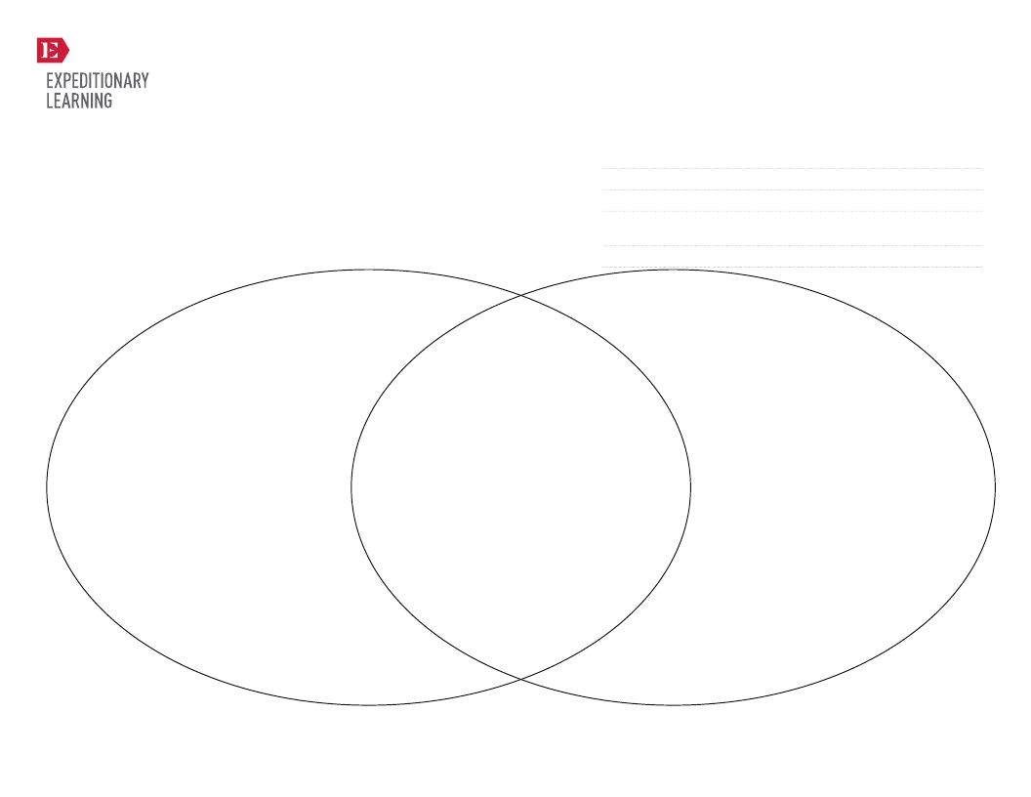

Conclusions in Analytical W riting

Created by Expeditionary Learning, on behalf of Public Consulting Group, Inc.
© Public Consulting Group, Inc., with a perpetual license granted to
Expeditionary Learning Outward Bound, Inc.

14

GRADE 6: MODULE 1: UNIT 3: LESSON 6
Narrative Story Line—
“Hero’s Journey”

Name:
Date:
Conclusions in Narrative

Name:

NYS Common Core ELA Curriculum • G6:M1:U3:L6 • June 2013 • 0

Text

Conclusion 1
Narrative Text

Qualities

GRADE 6: MODULE 1: UNIT 3: LESSON 6
What Makes the Conclusion of “The Golden Key”
Compelling? Note-Catcher

Name:
Date:

Evidence

Created by Expeditionary Learning, on behalf of Public Consulting Group, Inc.
© Public Consulting Group, Inc., with a perpetual license granted to
Expeditionary Learning Outward Bound, Inc.

15

NYS Common Core ELA Curriculum • G6:M1:U3:L6 • June 2013 • 1

Star:

Star:

Step:

Created by Expeditionary Learning, on behalf of Public Consulting Group, Inc.
© Public Consulting Group, Inc., with a perpetual license granted to
Expeditionary Learning Outward Bound, Inc.

GRADE 6: MODULE 1: UNIT 3: LESSON 6
Narrative Conclusion:
Stars and Steps

Name:
Date:

NYS Common Core ELA Curriculum • G6:M1:U3:L6 • June 2013 • 2

16

GRADE 6: MODULE 1: UNIT 3: LESSON 7
Transitions to Show Time and Place

Name:
Date:

Transitions are words or phrases that show relationships between ideas. Transitions give the reader a clue about what comes
next in a passage. Using transitions in your own writing will make your ideas flow from one to another.

Transition to Show Time

after

afterward

before

then

once

next

last

at last

at length

first

second

at first

formally

rarely

usually

another

Created by Expeditionary Learning, on behalf of Public Consulting Group, Inc.
© Public Consulting Group, Inc., with a perpetual license granted to
Expeditionary Learning Outward Bound, Inc.

17

Transitions to Show Space

at the left, at the right

in the center

on the side

along the edge

on top

below

beneath

under

around

above

straight ahead

surrounding

opposite

at the rear

at the front

in front of

NYS Common Core ELA Curriculum • G6:M1:U2:L7• June 2013 • 1

Transition to Show Time

finally

soon

meanwhile

at the same time

for a minute, hour, day, week, month, etc.

during the morning, day, week, month, etc.

most important

later

to begin with

afterward

generally

previously

in the meantime

eventually

Created by Expeditionary Learning, on behalf of Public Consulting Group, Inc.
© Public Consulting Group, Inc., with a perpetual license granted to
Expeditionary Learning Outward Bound, Inc.

18

GRADE 6: MODULE 1: UNIT 3: LESSON 7
Transitions to Show Time and Place

Transitions to Show Space

beside

behind

next to

nearby

in the distance

beyond

in the forefront

in the foreground

within sight

out of sight

across

under

nearer

adjacent

in the background

NYS Common Core ELA Curriculum • G6:M1:U2:L7• June 2013 • 2

GRADE 6: MODULE 1: UNIT 3: LESSON 7
End of Unit 3 Assessment:
Final Draft of Hero’s Journey Narrative

Write your best independent draft of your hero’s journey narrative that follows the hero’s journey archetype.

Be sure your narrative shows your best work with the writing skills we have been working on in class:

•
•
•
•
•
•

engage and orient the reader
follow the sequence of the hero’s journey archetype
use transitions to show time and place
show don’t tell (use dialogue, sensory details, and strong action verbs)
include a compelling conclusion
use correct capitalization and spelling

Created by Expeditionary Learning, on behalf of Public Consulting Group, Inc.
© Public Consulting Group, Inc., with a perpetual license granted to
Expeditionary Learning Outward Bound, Inc.

19

NYS Common Core ELA Curriculum • G6:M1:U2:L7• June 2013 • 3

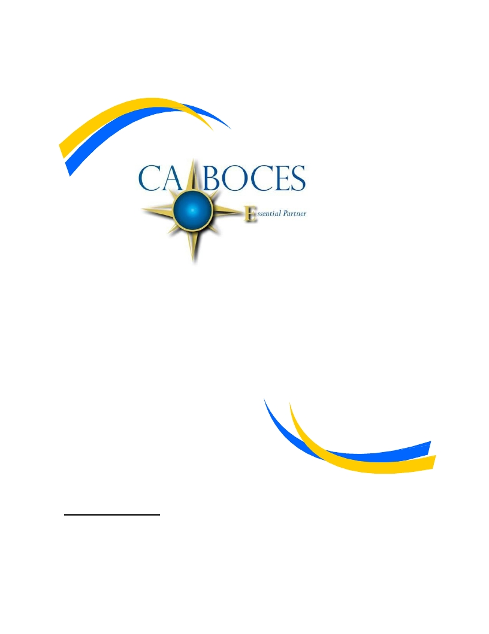

Equal Opportunity Notice

Learning Resources
CoSer 501
Educational Media

CA BOCES hereby advises students, parents, employees and the general public that it offers employment,
programs and educational opportunities, including vocational education opportunities, without regard to gender,
race, color, national origin, handicap or any other legally protected status. Inquiries regarding this non-
discrimination policy and grievance procedures may be directed to :
Human Resources Director, Cattaraugus-Allegany BOCES, 1825 Windfall Road, Olean, NY 14760; 716-376-
8237.

