Name:____________________________________________________________ Number:________________

T-Chart

Object one | Object two

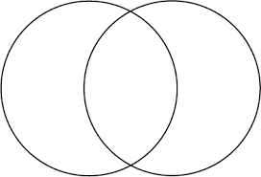
Name:_______________________________________ ______________ Number:_ _________

Venn Diagram

