Name:_______________________________________
Booklet directions

Indian Achievements

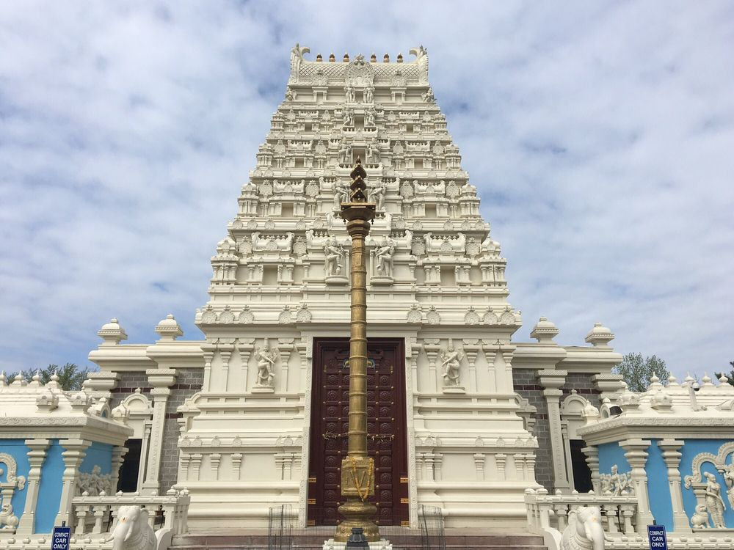

A) Read pages 172-176 in the social studies textbook.

B) Your task is to create a booklet depicting the Indian achievements of Early India. Use the information that is found on pages 172-176 in your textbook.

C) Your booklet will be at least 7 pages.

D) Each page will have a title with the name of the topic.

E) Each page will include at least four facts about each topic.

F) Each page will have a drawing or symbol representing the topic.

G) Be sure your work is neat.

H) Be sure your work is colorful.

I) Be prepared to share your ideas with the class during Circle Time.
      - ideas to consider:
        - After creating your booklet about Indian achievements, pick one achievement that you find most interesting. Share with the group at Circle Time the achievement you find most interesting.

Include at least 7 pages in your booklet, including these topics:

Page 1. Title page with your first and last name

Page 2. Temples, Paintings, and Sculptures (pages 172-173)

Page 3. Sanskrit Literature (page 174)

Page 4. Metalworking (page 174)

Page 5. Mathematics (page 175)

Page 6. Medical Science (page 176)

Page 7. Astronomy (page 176)

