Sixth Grade
End-of-Year Writing Assignment
César Chávez

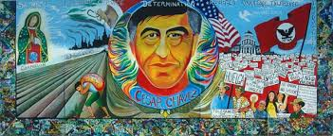

600 × 246 - interactioninstitute.org

How would you describe César Chávez?

Write an essay describing his character traits.
Sixth Grade
End-of-Year
Writing Assessment
Directions:
- Read the articles about César Chávez.

- How would you describe César Chávez? Write an essay that describes the character traits of César Chávez.

- Create a rubric (or use a template that is provided) to set goals for your writing and to self-assess your writing after the essay is completed.

- Create an outline (or use an outline that is provided) to help guide your work.

- In your essay, write an inference/claim that describes the character traits of César Chávez.

- List evidence from the texts to support your inference/claim.

- Use the Extended RACE Format to complete this assignment.

- Write as much as you can, as quickly as you can.

- In your writing, make sure you:
- Write your inference/claim in your introduction.
- Use transition words and writing prompts to start new paragraphs and to introduce and explain new examples from the text.
- Give many examples from the text as your evidence to support your inference/claim.
- Write a compelling conclusion.

- Check your writing for:
  - spelling
  - capitalization of proper nouns
  - capitalization of the beginning of sentences
  - punctuation
  - indentation of each new paragraph
  - interesting word choice
  - See the rubric for more details of expectations.
César Chávez Biography
http://www.biography.com/people/cesar-chavez-9245781

APA Style
Cesar Chavez. (2015). The Biography.com website. Retrieved 03:44, May 14, 2015, from http://www.biography.com/people/cesar-chavez-9245781.

Harvard Style
Cesar Chavez. [Internet]. 2015. The Biography.com website. Available from: http://www.biography.com/people/cesar-chavez-9245781 [Accessed 14 May 2015].

MLA Style
"Cesar Chavez." Bio. A&E Television Networks, 2015. Web. 14 May 2015.

Cesar Chavez Biography
Activist (1927–1993)

Quick Facts
Name
Cesar Chavez
Occupation
Activist
Birth Date
March 31, 1927
Death Date
April 23, 1993
Place of Birth
Yuma, Arizona
Place of Death
San Luis, Arizona
Full Name
Cesar Estrada Chavez
Cesar Chavez

Union leader and labor organizer Cesar Chavez dedicated his life to improving treatment, pay and working conditions for farm workers.

Synopsis
Born near Yuma, Arizona, on March 31, 1927, Cesar Chavez employed nonviolent means to bring attention to the plight of farmworkers, and formed both the National Farm Workers Association, which later became United Farm Workers. As a labor leader, Chavez led marches, called for boycotts and went on several hunger strikes. It is believed that Chavez's hunger strikes contributed to his death on April 23, 1993, in San Luis, Arizona.

Early Life
Union leader and labor organizer Cesar Chavez was born Cesario Estrada Chavez on March 31, 1927, near Yuma, Arizona. Chavez dedicated his life to improving the treatment, pay and working conditions for farm workers. He knew all too well the hardships farm workers faced. When he was young, Chavez and his family toiled in the fields as migrant farm workers.

Labor Leader
After working as a community and labor organizer in the 1950s, Chavez founded the National Farm Workers Association in 1962. This union joined with the Agricultural Workers Organizing Committee in its first strike against grape growers in California in 1965. A year later, the two unions merged, and the resulting union was renamed the United Farm Workers in 1972. In early 1968, Chavez called for a national boycott of California table grape growers. Chavez's battle with the grape growers for improved compensation and labor conditions would last for years. At the end, Chavez and his union won several victories for the workers when many growers signed contracts with the union. He faced more challenges through the years from other growers and the Teamsters Union. All the while, he continued to oversee the union and work to advance his cause.
As a labor leader, Chavez employed nonviolent means to bring attention to the plight of farm workers. He led marches, called for boycotts and went on several hunger strikes. He also brought the national awareness to the dangers of pesticides to workers' health. His dedication to his work earned him numerous friends and supporters, including Robert Kennedy and Jesse Jackson.
It is believed that Chavez's hunger strikes contributed to his death: He died on April 23, 1993, in San Luis, Arizona.
“If you really want to make a friend, go to someone's house and eat with him...The people who give you their food give you their heart.”
—Cesar Chavez

An American Hero
The Biography of César E. Chávez

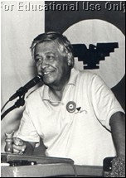

Photo copyright © Jocelyn Sherman

César E. Chávez was a good man who dedicated his life to helping others.
César was born to parents who taught him important ideas about hard work, the importance of education, and respect.
As a young boy, César worked on his family’s farm feeding and watering the animals, collecting eggs, and bringing water to the house.
César’s parents thought school was important. School was hard for César because the teachers only spoke English and César did not understand English. César thought some teachers were mean because they would punish him when he spoke Spanish. César learned to read English in school and he learned to read Spanish from his uncles.

César’s parents were very strict and taught him and his sisters and brothers to show respect to others.
His parents also taught him that it was important to help others. César and his family often helped his uncles, aunts, and cousins by giving them food when they had little to eat.

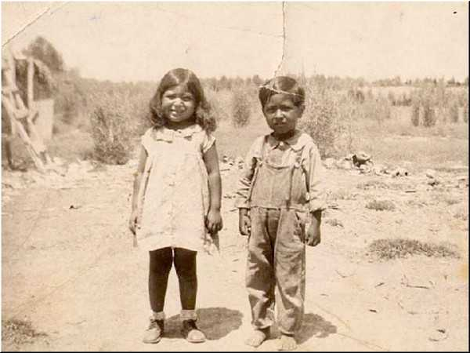

Photo Courtesy of César E. Chávez Foundation
César and his sister are standing outside their home.

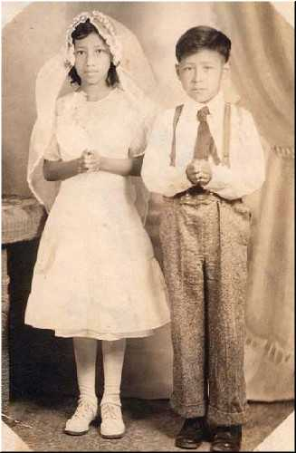

Photo Courtesy of César E. Chávez Foundation
César and his sister are dressed for their First Holy Communion.

César’s grandmother, Mama Tella, taught him about the importance of their religious faith and to have a strong belief in God. When César grew up, he would remember and practice what his grandmother had taught him. For César, religion was a most beautiful thing.

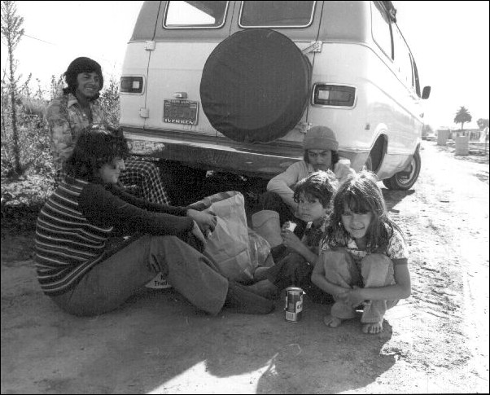

Photo Copyright © Manuel Echavaria
In 1975, this farm worker family is eating lunch along side
the fields in the Santa Maria Valley in the shade of their
van because there is no other shade available.

When César was ten years old, his family’s home was taken away from them because they did not have enough money.
César’s family moved to California to find work. They began working on farms picking fruits and vegetables. César’s family would move from farm to farm looking for work, just like many other families who also lost their homes.
César’s family moved often. Moving did not bother César, or his sisters and brothers too much because their parents loved them and because they were always happy to be together as a family.

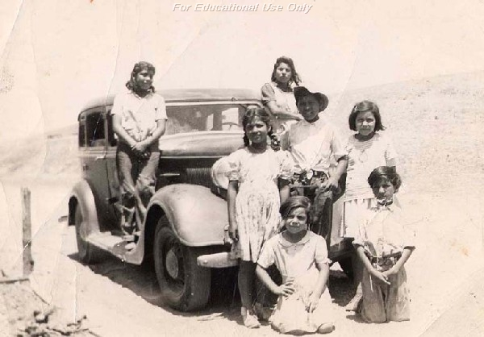

Photo Courtesy of César E. Chávez Foundation
César and his brothers and sisters in front of the family car

Working on the farms was very difficult. Farm workers like the Chávez family would very long hours. They often had few bathrooms and little clean water to drink. Farm workers suffered a lot and they were not treated with respect or dignity.

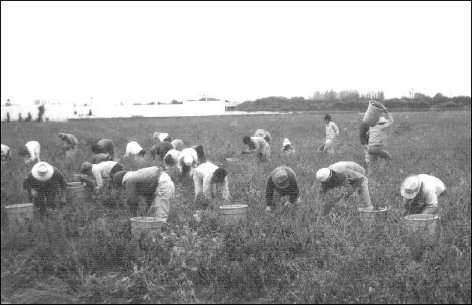

Photo Copyright © Manuel Echavaria
These farm workers are picking chili at Santa Maria in 1971.

César’s family worked very hard on the farms, but they made very little money. Everyone in the family had to work, even the children. To make things worse, sometimes the men in charge of the farm workers would cheat and steal money from the farm workers, including César’s family. These men would often run away so they would not get caught.
César’s family had very little money and many times they did not have enough food to eat. César and his family never thought of themselves as being poor. César’s mother would often tell César and his brother Richard to find homeless and hungry men so she could cook them a meal.

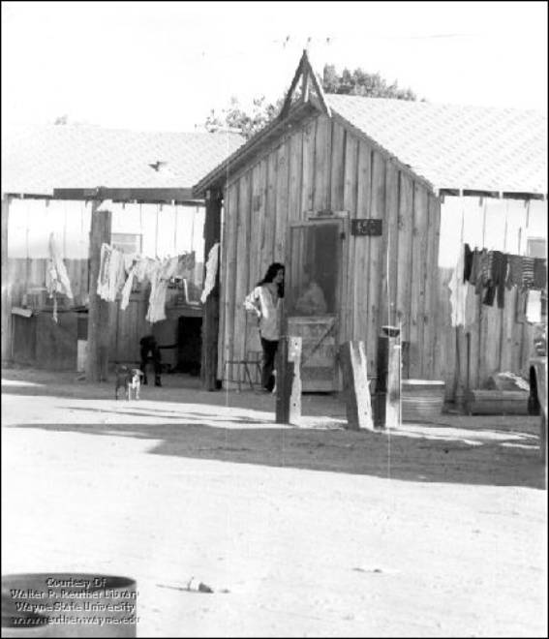

Photo by Cris Sanchez, Courtesy of United Farm Workers
In a migrant farm worker camp, the ladies are visiting while
their laundry dries on the clothesline strung between their houses.

When César was a teenager, he and his older sister Rita would help other farm workers and neighbors by driving them to the hospital to see a doctor. Without César’s and his sister’s help, these people would have had a very difficult time getting a doctor’s help.
The people César helped often wanted to give him a little bit of money to pay for gas and for his help. César never took any of their money because his mother would have been mad at him. She used to say, “You always have to help the needy, and God will help you.”

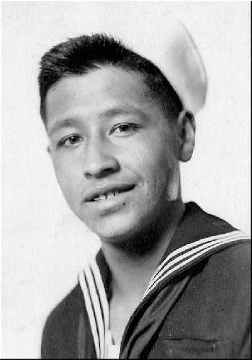

Photo Courtesy of César E. Chávez Foundation
César in his U.S. Navy uniform.

A few years later, César volunteered to serve in the United States Navy. César, like many American men and women, served in the military to fight for freedom and to protect the people of the United States.

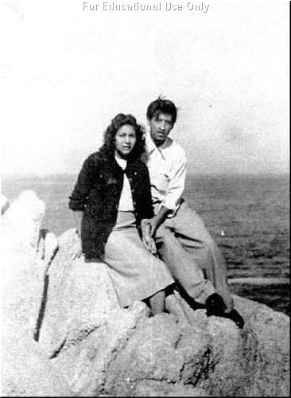

Photo Courtesy of César E. Chávez Foundation
César and his wife, Helen, posed for their picture by the seashore.

After two years in the Navy, César returned home and married his girlfriend, Helen. After a short time, they moved to San Jose, California and began a family.

Life changed for César when he met a man named Fred Ross. Fred Ross believed that if people worked together they could make their community better. Fred Ross hired César to work for him in the Community Service Organization.
The Community Service Organization worked to help people. César now worked to bring people together to identify problems and find ways to solve their problems. Many problems were not solved because community leaders did not respect all people.
César, Fred Ross, and the Community Service Organization helped people in the community learn how to vote. They also taught people that community leaders respected voters. Community leaders worked harder to solve the problems of voters. César worked in many communities in California to help people gain the respect they deserved.

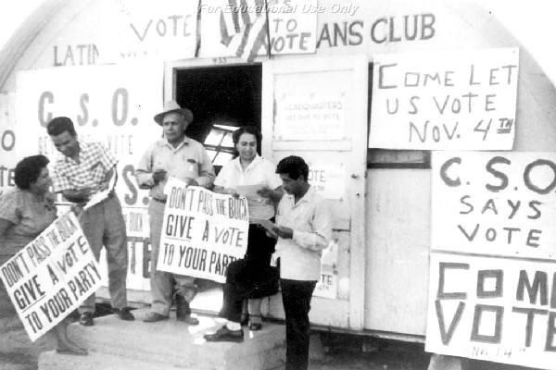

Photo Courtesy of César E. Chávez Foundation
César and other people from the Community Service Organization
are getting ready to try to get the farm workers to vote.

After helping many people gain the respect of community leaders, César left the Community Service Organization to help farm workers gain the respect and dignity they deserved.
César started the National Farm Worker Association to help improve the working conditions of farm workers. African Americans, Filipinos, white Americans, Mexican Americans and Mexicans, and men and women of all backgrounds joined César.

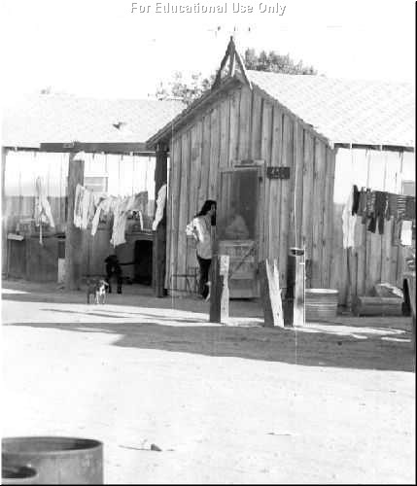

Photo by Cris Sanchez
In a migrant farm worker camp, the ladies are visiting while
their laundry dries on the clothesline strung between their houses.

César and the farm workers wanted the companies and growers that owned the farms to respect farm workers by providing them with fresh water to drink, bathrooms in the fields, and fair pay for a day’s work.
The companies and growers refused to treat the farm workers with respect and dignity. The growers did everything they could to stop César and the farm workers. They even turned to violence and hurt many farm workers and people who helped the farm workers. This made César very upset.

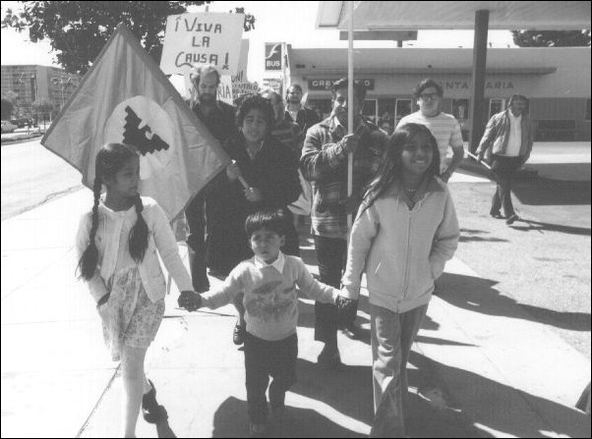

Photo Copyright © Manuel Echavaria
People of all ages marched to Preisker Park while
participating in a demonstration in 1972.

César did not believe in violence. Like Martin Luther King, César wanted to bring change in a nonviolent way. Many people came to help César. Many people supported César because he believed in nonviolence. Like César, they also believed that farm workers deserved better treatment, respect, dignity, justice, and fairness.

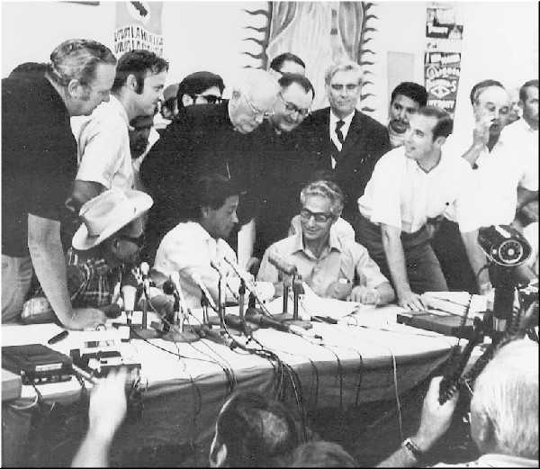

Photo Courtesy of United Farm Workers
César is signing an important agreement while many union supporters
watch with reporters from radio stations and newspapers.

César worked hard. He suffered and sacrificed a lot to make farm workers’ lives better
After five years, some growers in California agreed with César and started to provide farm workers with fresh water to drink, bathrooms, and better pay. César, the farm workers, and their friends won, making farm worker’s lives better.

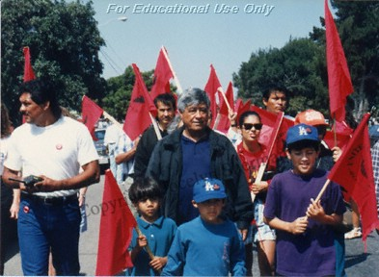

Photo Copyright © Jocelyn Sherman
César marching again with many supporters.

César dedicated the rest of his life to making the world a better place and to serving others. He continued to work to bring respect, dignity, justice, and fair treatment to the poor, to farm workers, and to people everywhere.

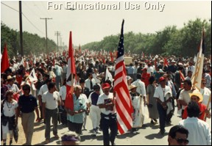

Photo Copyright © Jocelyn Sherman
Many people came to César’s funeral.

César died on April 23, 1993. He was sixty-six years old. People all over the world remember César E. Chávez as a man of courage who fought to improve the lives of all people.

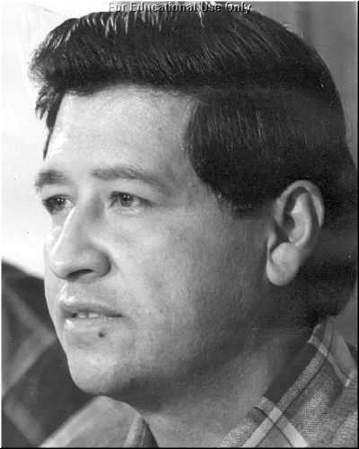

Photo Courtesy of the César E. Chávez Foundation

César E. Chávez is an American hero.
His legacy lives on!

