Name: ____________________________________

Changes Narrative:

Writing a Story about Change

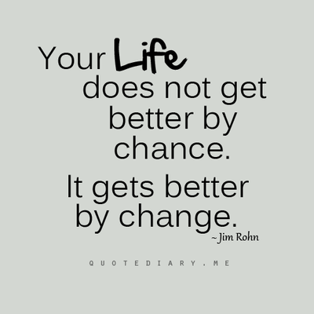

Directions

You will be writing a narrative about a character that goes through a personal change.

During your writing process be sure you:
- Identify a theme that you will use throughout your narrative.
- Decide what conflict will take place during your story.
- Fill out the Roller Coaster Plot Diagram to help you organize your ideas about the main character, the setting, the plot, and the changes that take place. This diagram will help you organize your paragraphs.
- Use transition words to start new paragraphs and to show time and place.
- Show, don’t tell (use dialogue and vivid details).
- Write a conclusion that provides closure for your story – what change happens? What is the result?

When you are editing, make sure you use the COPS editing checklist and the Narrative Writing Checklist.

Small Moments

Think of a person that matters to you. List small moments that are connected to him or her.

Think about a place that matters to you. List small moments that occurred at that place.

“Show, Don’t Tell!”

“Show, Don’t Tell” is a:

Descriptive writing paints a picture for the reader.

For example:

A) The sky is blue.

OR

B) The sky above was the color if a robin’s egg and was scattered with fluffy white clouds that made Jimmy want to fly away with them.

Which one is more descriptive?

_____________________________________________

Ways to “Show”
Use sensory language:
- Sensory words engulf the reader’s five senses
- The five senses are:

- Words like dazzling, melodious, rough, bitter, or pungent are GREAT examples.
Use strong action verbs:
- Strong action verbs have a greater impact on your reader.
- Avoid words like dislike, love, run, etc. Use instead, words like avoid, detest, admire, adore, cherish, dart, dash, or scurry.

What is descriptive writing?

What do you think?
What is a better example of descriptive writing?
Example A:
Carter was sick of living a lie. He was sad and angry, so she slammed her bedroom door.
OR
Example B:
“I’m tired of pretending!” Carter shouted, tears streaming down his face, before slamming the door behind him.

Dialogue

What is dialogue?

- Dialogue is conversation given in a written story or play.
- If the characters in a story are talking, you write what they are saying as dialogue.

What does dialogue look like?

Owen and Larry are on a trip to the city and look out from a restaurant window.

“Have you ever been here?” Larry asked.

“Yes, my family takes trips here all of the time!” Owen answered excitedly. “I love it here.”

Tips for Good Dialogue

- Say your dialogue out loud. Does it make sense?
- Do not use ONLY dialogue or ONLY description. Good writers take the time to use both.
- Make sure that your dialogue is only 1 or 2 lines long. It should not take up an entire paragraph.
- Dialogue should move your story forward. It must have a purpose.
- Use varied dialogue tags (see next page)

Dialogue Rules
- Always start a new paragraph when a NEW character is talking.
- Use quotation marks at the beginning and ending of each piece of dialogue.
- Use correct punctuation.
- Periods, question marks, exclamation points, and commas go INSIDE the quotation marks.
- “I love writing!”
Dialogue Tags

What are dialogue tags?
- A combination of TWO words that define who is speaking
- “I love pumpkin pie,” said Victoria.

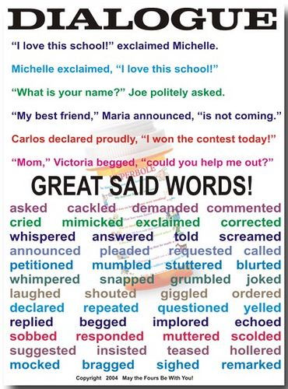

Please write a short conversation using dialogue. Make sure that you are following all of the rules and using dialogue tags!

Brainstorm

What are some ideas that you will want to write about in your Changes Narrative Essay?

Before you write, think about:

- The Roller Coaster Plot Diagram
- The theme of your narrative
- The uses and rules of dialogue – what makes the dialogue effective?
- Dialogue tags
- Descriptive writing – sensory language and strong action words
- Words and phrases that draw the reader in.

Your Changes Narrative Essay paragraphs should follow the Roller Coaster Plot Diagram. This will help the paper flow.

*Remember that your character needs to go through a change.*

Outline

Paragraph 1:
- Exposition -introduce your character and setting
- Where and when does the story take place?
- What is your character doing? What are some of the character traits that he or she has?
- Are there any other characters that need to be introduced?

Paragraph 2:
- What starts the conflict?
- What problem does your character face?
- What is your character thinking? What does he or she need to do?
- Include dialogue, descriptive, and sensory language.

Paragraph 3:
- Rising Action
- What are some of the obstacles that your character faces?
- Obstacle #1
- Obstacle #2
- Obstacle #3 (EXTRA)
- Include dialogue, descriptive, and sensory language.

Paragraph 4:
- Climax – action reaches its highest point
- What decision does your character need to make?
- What can he or she do to make that decision?
- This is your “crisis” point. What is the biggest problem does he or she faces?
- Include dialogue, descriptive, and sensory language.

Paragraph 5:
- Falling Action – what happens after the big decision is made?
- Include details.
- How does this affect the character and those around them?
- This is the “wrap it up” paragraph before your conclusion.

Paragraph 6:
- Conclusion
- How has your character changed after going through all of the obstacles and making decisions?
- What lessons have they learned?
- How has this changed their life?

*Make sure you include your THEME throughout the story. If your character was fearful, they should be brave at the end of it*

