International country project:

Country Map and Flag

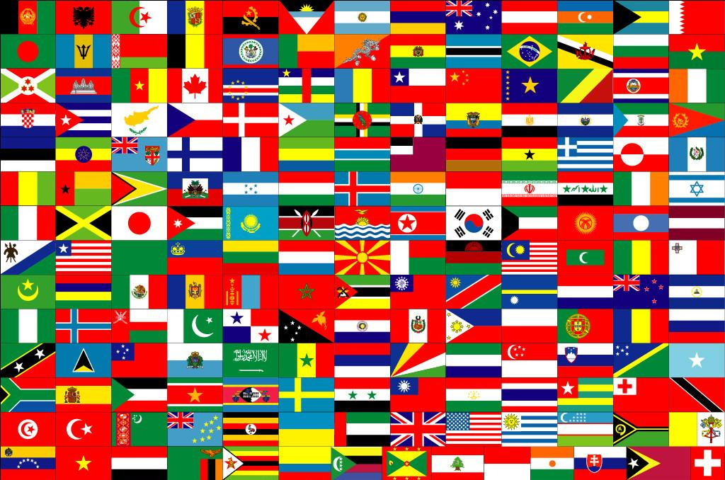

Create a flag and a map of your country:
- Step One: Using the websites provided below, or a website of your choice, draw the flag of the country you wish to visit.
- Step Two: Using the websites provide below, or a website of your choice, draw a map of the country you wish to visit.
- Step Three: Label key cities on the country map.
- Step Four: Label key geographic features on the country map.
- Check out Mrs. Looney’s Class Website to get ideas for your map and flag of your country. http://mrslooney.weebly.com/sixth-grade-international-case-study.html Once on the webpage, scroll down to see sample drawings of maps and flags that have been created by students in the past of countries that they wished to "visit."
If applicable, include the following geographic features on your country map:
  - islands
  - deserts
  - rivers
  - peninsulas
  - plateaus
  - plains
  - deltas
  - mountains
  - beaches

MAPS AND FLAGS WEBSITES:
- https://www.coloring.ws/countries.htm
- https://www.countries-ofthe-world.com/flags-of-the-world.html
- https://www.sciencekids.co.nz/pictures/flags.html
- https://www.worldatlas.com/quizzes/how-many-world-flags-can-you-identify/1/
- https://flagpedia.net/
- https://www.britannica.com/
- https://www.cia.gov/library/publications/the-world-factbook/
- https://www.google.com/earth/
- https://legacy.lib.utexas.edu/maps/map_sites/country_sites.html
- http://ontheworldmap.com/
- https://www.worldatlas.com/
- https://www.infoplease.com/atlas
- https://www.mapsofworld.com/world-atlas/
- https://www.ducksters.com/geography/usgeography.php
- https://www.worldtravelguide.net/
- https://kids.nationalgeographic.com/
- https://www.natgeokids.com/uk/
- https://geology.com/world/world-map.shtml
- https://www.coloring.ws/japan.htm

