Hero’s Journey

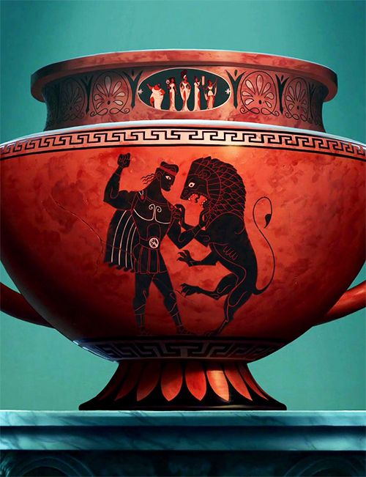
6th Grade Writing

