Name:_______________________________________
Project
Directions:

Topic of Your Choice

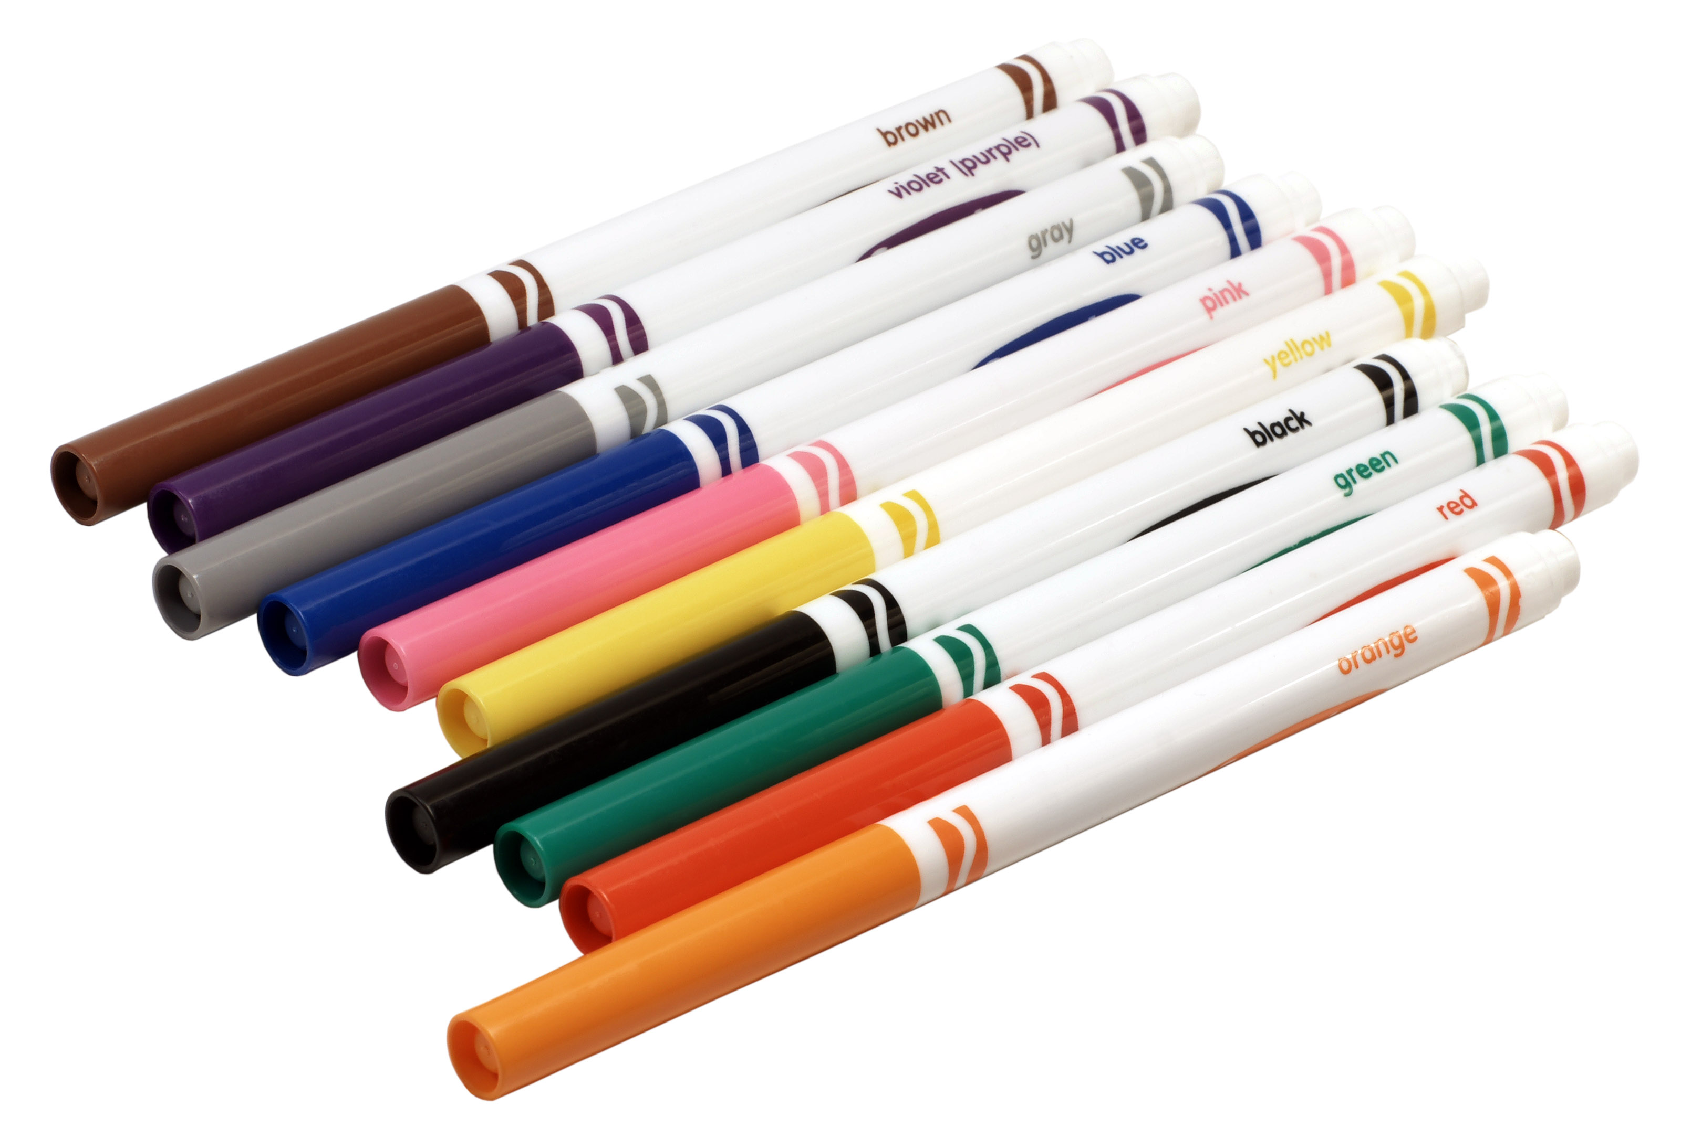

- It is my hope that these projects will help each student continue with the hard work he or she has put forth this entire school year. It is my hope that these projects will be interesting, inspiring, and rigorous.
- I am hoping that each student will complete at least one project each of the weeks that we are out of school. So, for example, if school is closed for three weeks, I am hoping that each student will complete at least three different projects. I would love it if each student would complete at least one project per week. Some projects will be longer or shorter than others. This is just a guide. If you are working on one topic for longer than a week, that is fine as well.
- These projects will help keep students’ minds engaged in learning, will keep their reading skills intact, and will help students continue with the amazing writing that they have put forth all year.
- I hope that you will be as creative as possible.
- I look forward to students sharing their creations online during our Zoom meetings.
- Please feel free to email me with any questions or concerns. We can set up a phone conversation if you would prefer. llooney@sciocsd.org

DIRECTIONS:

- Pick a topic of your choice. See the list of topics for ideas.

B) Your task is to create a project, booklet, poster, PowerPoint, typed Word Document, hand-written essay, blog, video, comic, poem, play, or any other creation (diorama, mobile, 3D creation) depicting important facts on a topic of your choice. Mrs. Looney will provide a few informative texts that can help as you write about your topic. Two informative packets are being sent to the sixth graders and two magazines are being sent to the fifth graders. For students with access to the internet, you may use information that you find on the internet to read about and gather information about your topic. Be sure to ask an adult in your home for permission to use the internet. I will also post interesting articles on my website and will post other ideas for projects on my website each week.

C) It would be lovely if each of your projects contained at least 5 different topics. For example, if you are creating a PowerPoint, the PowerPoint will contain at least five different slides with five different headings. If you create a booklet, your booklet will have at least five different pages with information on five different topics. Each booklet could have a title page and subtitles on the other pages with the names of the five topics.

D) It would be wonderful if you could include at least four facts (or more) about each topic. So, if you have five different topics, and at least four facts per topic, your project will include at least twenty facts.

E) It would be fantastic if you included several drawings, photos, or symbols representing the topics.

F) If you choose to create a Blog or essay: A great way to improve your reading and writing skills is to contribute your thoughts to a blog. Feel free to take some time to write on our blog on Mrs. Looney’s website about the project that you are creating or other thoughts that you might have about the topics that you are reading about and interested in. Be sure to write in complete sentences with correct grammar, spelling, sentence structure, and punctuation. Be sure to use as many descriptive sophisticated words as possible. Read other people's comments and contribute with your own opinions about the books you have read or topics that you are reading about. Try to write at least five descriptive paragraphs to explain your book, topic, or ideas. You may also write five paragraphs to discuss ideas that you have about a social studies topic or person in history. I highly recommend that you write your thoughts in a Word document first and then copy and paste your work onto Mrs. Looney’s blog, if you wish.

G) PowerPoint: Another way to improve your writing and technical skills is to produce a PowerPoint on a topic of interest, including about a person in history or a social studies topic. Produce a PowerPoint with many writing points. Add music, if possible. Be sure that the music relates to your topic. For example, if you are writing about the Civil War, maybe include music from the Civil War era on your PowerPoint. If you are writing about Ancient Greece, you may want to have Greek music in the background. You may also take time to create a PowerPoint about the books that you are reading or about thoughts regarding writing. Be sure to write in complete sentences with correct grammar, spelling, sentence structure, and punctuation. Be sure to use as many descriptive sophisticated words as possible. Write as many descriptive paragraphs and slides as you deem necessary to explain your book, topic, or ideas. You may also write paragraphs and slides to discuss ideas that you have about a social studies topic or person in history.

H) Apps: Complete a writing project or creative video on your iPad, iPod, phone, or other device. There are many fantastic Apps for writing and for documenting your thoughts.

- Create a PowerPoint that shares all about you. What is something really important that you would like to share about yourself. What do you like to do? How would you describe your character traits? What are your hopes and dreams? What is a talent that you have that others don’t know about? What are some of the most important things/ideas/concepts/values/people in your life?

- Create a photo book. When Mrs. Looney has time, she creates photo books for her family on SnapFish. I know other people who have used Shutterfly. Maybe I will create one when I have some time while being home! These books can be expensive, but if you wait for the right moment, there are many good sales to purchase the book. You can create your book and save it online and wait for a sale. Mrs. Looney loves including photos of family and friends, photos of her flowers in her garden, photos of nature scenes. The part that I love best is arranging the pages in themes. And then I love looking for quotes and poems that relate to the theme and to the photos. For example, my son loves fishing and so I included several pages of his fishing pictures from when he was younger until present day. And then I found really great quotes about the importance of fishing and how it is a form of peace and meditation and prayer for some people, a time to remain still in our busy world.

- Handwritten report or project: Any of the above projects can be completed by hand with pencils, pens, crayons, or markers on paper or posters.

- Remember that Mrs. Looney loves neat and colorful work! Sharpies are awesome and make our work look professional.

- Be creative. Enjoy what you are creating. Work hard. Have fun.

- The goal and focus of these projects are on creativity. But, another major goal is the keep writing and to write as much as possible. To be a better writer you need to read as much as you can and to write as much as possible. Be sure that you are taking pride in your work. Be sure you are using correct punctuation, grammar, sentence structure, and capital letters where they need to be and lowercase letters where they need to be. Also, be sure to use as many sophisticated words that you can. Don’t forget your transition words. Don’t forget using RACER. This is what takes your writing to a higher level. Use similes. Use metaphors. I had a sixth grader write me an email and included a simile. It totally made my day!

- I look forward to seeing your creations!

Ideas for Research Topics and Writing Topics:

These are only suggestions. Write about what interests you most. Try to create one project per week.

- Create a project about the books that you are reading.
- Choose a topic on the Fifth and Sixth Grade Creative Writing List and write a creative essay. (The List is in the packet that was delivered from Scio.)
- Write letters to friends, family members and relatives.
- Make thank you cards to people you care about.
- Write on Mrs. Looney’s blog about the books you are reading or topics that interest you. Or write on loose-leaf or in your journal.
- Write a poem to be recited when we meet during our Zoom meeting. Submit a poem to Mrs. Looney’s blog.
- Create your own website. Weebly is an easy, free way to get started. Make sure you get permission from your parents first!
- Create a project about all the interesting things that you have discovered in your yard.
- Create a project about scores from your favorite sports.
- Draw pictures. Write about the pictures.
- Take a photo and post it on your parents’ Instagram (with parental permission only). Write a short poem and add it to your comments of your photo.
- Create a project about your favorite musicians, artists, and/or songs.
- Create a project with recipes for your favorite foods.
- Design a menu. Create a plan for a restaurant or bakery.
- Read interesting articles from the internet, newspaper, or magazines and write about your thoughts about the topic.
- Be a reporter. Write a newspaper article. I believe that Office 365 Word has a template. Ask Nathan how to create it! Create your own newspaper.
- Be a sports reporter. Report about a ball game that you watched or write about a made-up competition.
- Write your own song.
- Design dance steps. Create a project about a certain type of dance and its history.
- Write out some plays for your favorite sport.
- Create and describe a science experiment.
- Create a project about something new that you learned from the Internet (with the permission of your parents).
- Write down the dreams that you had while you were sleeping.
- Create a project about your dreams for the future.
- Create a project about a career or profession you are interested in.
- Create a project about some colleges that you are interested in.
- Create a project about a trip that you wish to take.
- What are hobbies? Create a project describing your hobbies. Why do you like it? Tell me something that I don’t know about your hobby.
- Are you a makeup artist? I know that there are sixth graders who are extremely talented at makeup design (and parents, too!). During Halloween and during Blue and Gold days there were some very interesting designs. Makeup your face and create a story about that “costume” or creation.
- Are you a mechanic? Do you like motor sports? This is something that Mrs. Looney doesn’t know anything about. Convince me that I need to try different motor sports. What would I like about it? What would I learn?
- Does your family plant a garden? Mrs. Looney loves her flower gardens but wants to start a vegetable garden WHEN THE SNOW MELTS. What do I need to know? What are the steps that I need to take? Does your family have tricks of the trade that I should know? Which veggies are the easiest to grow, the most likely to survive? Which are the hardest to grow? How do I protect my garden from the deer that visit my yard every morning and evening?
- Have you ever built a fort in the woods? What materials did you use? What types of adventures take place in the fort?
- Create a project about a major historical event. I am thinking about a particular sixth graders that loves to watch the history channel and knows quite a bit about the US involvement in several wars throughout the history of our country. Why did the war start? What was the United States involvement? Did we reach our goal? What were some of the positive effects of the war? What were some negative effects of the war? How did this war affect every day people and their families in the United States and in other countries? What was the economic effects of the war?
- Do you know any card tricks? Can you learn a card trick and teach it to the class during a Zoom meeting?
- Write a biography about an extraordinary person who has made a difference in the world. Tell a little about the person’s background. What did the person do that is important? What are some of this person’s character traits? Do you have any character traits that are similar to this person? In what ways do you wish to emulate this person (be like this person)?
- Write a story.
- Write a play. Create costumes. Create props. Can you write a historical fiction play (a play about history)? Can you write a play that takes place in an ancient civilization? A play about the Greek or Roman gods?

And the list goes on and on and on….
Create a project about whatever interests you.
But be sure to write and create!
Enjoy!

Fifth Grade Magazine

(I am hoping that this magazine was delivered to your house. If not let me know.)

The New Nation

Fifth Grade Sample Social Studies Projects:
Using “The New Nation” magazine.

Include at least 6 topics in your project, including these topics:

Cover: The New Nation, title page with your first and last name

Topic 1. New Waves of Immigrants (pages 2-3 in the magazine)

Topic 2. Overland Routes West (pages 4-5 in the magazine)

Topic 3. Waterways to the West (pages 6-7 in the magazine)

Topic 4. Pioneers Settle New States and Territories (pages 8-9 in the magazine)

Topic 5. Exploring the West (pages 12-13 in the magazine)

Topic 6. War of 1812 (pages 14-17 in the magazine)

Fifth Grade Magazine

(I am hoping that this magazine was delivered to your house. If not let me know.)

America 1492

Fifth Grade Sample Social Studies Projects:
using the “America 1492” magazine

Include at least 6 topics in your project, including these topics:

Cover: America 1492, title page with your first and last name

Topic 1. The First Americans (pages 2-3 in the magazine)

Topic 2. Sea People of the Pacific Northwest (pages 4-5 in the magazine)

Topic 3. Peoples of the Desert Southwest (pages 6-7 in the magazine)

Topic 4. Farmers of the Great Plains (pages 8-9 in the magazine)

Topic 5. Wildlife in 1492 (pages 10-11 in the magazine)

Topic 6. Eastern Woodland Peoples (pages 12-13 in the magazine)

Topic 7. Mound Builders of the Southeast (pages 14-15 in the magazine)

Sixth Grade Informational Packet

(I am hoping that this informational packet was delivered to your house. If not let me know.)

Muslim Empires

Sixth Grade Sample Social Studies Projects

Include at least 6 topics in your project. You may choose to include these topics:

Cover: Muslim Empires, title page with your first and last name

Topic 1. Beginnings of Islam

Topic 2. Islamic Beliefs

Topic 3. The Ottoman Empire

Topic 4. The Safavid Empire

Topic 5. The Mughal Empire

Topic 6. Cultural Achievements

Sixth Grade
Informational Packet

(I am hoping that this informational packet was delivered to your house. If not let me know.)

Ancient China

Sixth Grade Sample Social Studies Projects

Include at least 6 topics in your project. You may choose to include these topics:

Cover: Ancient China, title page with your first and last name

Topic 1. The Chinese Empire

Topic 2. Ancient Chinese Society

Topic 3. How the Rich Lived

Topic 4. How the Poor Lived

Topic 5. The First Dynasties

Topic 6. Chinese Inventions

Topic 7. The Great Wall

Topic 8. Legacies of Ancient China

