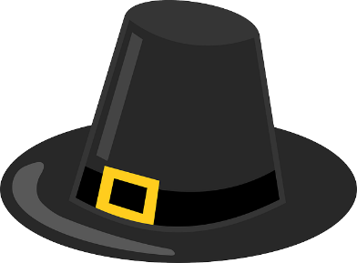
Name _______________________________
Date _____________________

Founding the New England Colonies Scavenger Hunt

Directions: Read through pages 4 and 5 of your “13 Colonies” magazine. Answer the questions in complete sentences. Highlight the answers in your magazine.

1. What name was given to the people who first landed at Plymouth?
______________________________________________________________
2. Who issued a charter, or written grant, that allowed Puritans to colonize Massachusetts?
______________________________________________________________
3. What did the laws and policies reflected by the Puritans reflect?
______________________________________________________________
4. Why were the pilgrims called separatists?
______________________________________________________________
5. Who was the first governor of Massachusetts?
______________________________________________________________
6. What did the Puritans force people to do if they disagreed with them?
______________________________________________________________
7. What was the name of the colony created when Portsmouth combined with other settlements?
______________________________________________________________
8. Who is called the “Father of Connecticut”? (Circle one.)
King Charles I David Thompson
Thomas Hooker John Haynes
9. What is the name of one of the earliest constitutional documents in the colonies?
______________________________________________________________
10. What did Puritans believe in?
______________________________________________________________
11. Circle the main idea of this section, “Founding the New England Colonies”. (Remember the trick for finding the main idea in the magazines.)
A. More than 1,000 Puritans established the Massachusetts Bay Colony in 1630.
B. The Pilgrims wanted to separate from the Church of England.
C. Thomas Hooker and John Haynes left Massachusetts and formed the Connecticut Colony.
D. Over the course of the next half century, the Puritans played an important role in settling New England.

