Name:_______________________________________
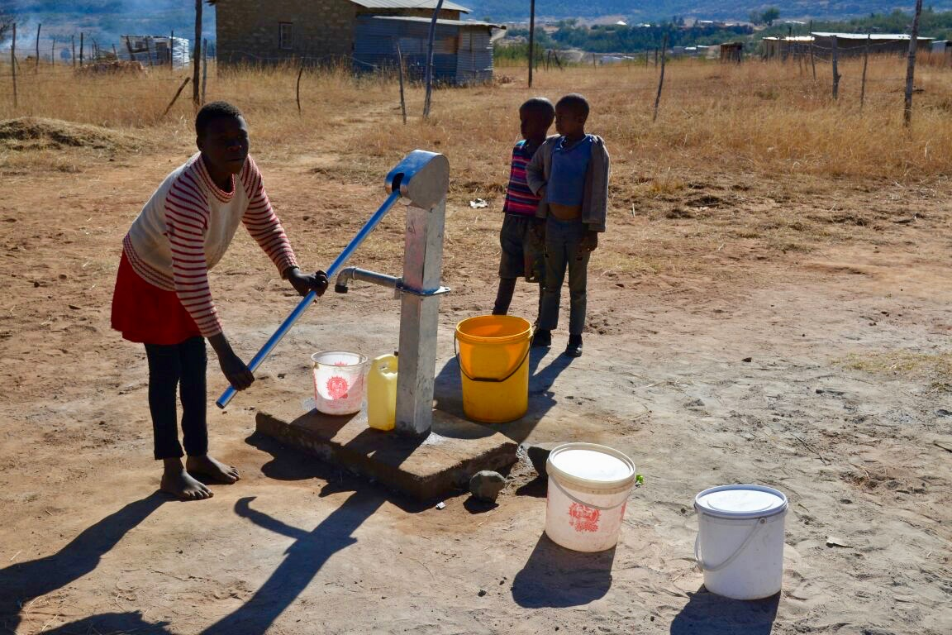
Directions:

RACER
Assessment

How did Ryan
make a difference
in the world?

- Read the article “Ryan’s Well.” http://www.scholastic.ca/education/movingupwithliteracyplace/pdfs/grade4/kidscandoit/21-ryanswell-sb.pdf

- Answer the question: How did Ryan make a difference in the world?

- Write a two-paragraph short answer response as you answer the above question.

- Use the RACER resources found on the TEAMS Assignment page and on Mrs. Looney’s website to help remind you how to answer a question using RACER.
  - RACER Resources:
    - RACEEECEEER GRAPHIC ORGANIZER
    - RACEEECEEER RUBRIC
    - RACEEECEEER WRITING PROMPTS

- Add a heading and a title to your answer. See below for an example. If you wish, you may use the WORD DOCUMENT template provided to help you with your typing.

- Do your very best work, as this is your time to shine and show Mrs. Looney what you know about INFORMATIVE writing and using the RACER graphic organizer.

- INDENT EACH NEW PARAGRAPH!

- CHECK YOUR SPELLING!

- ARE YOU USING CAPITAL LETTERS CORRECTLY?

- Your answer should be at least two paragraphs long. Each paragraph should have at least five sentences. Include a topic sentence, one quote, and three explanations for each paragraph. So, in total, you should have at least ten sentences.

- Submit the assignment on TEAMS.

Sample Heading:

This is what your heading should look like:

Sam Loves-to-Read (made-up student name)
Mrs. Looney
Writing 5 (or Writing 6, depending on which grade you are in)
11 January 2021
(This is how the rest of the world writes the date. And this is how many college professors will want you to write the date when you are in college. It is using the MLA format.)

TEMPLATE: RACER Assessment

Type right into this template on a Word Document, to make your work easier, if you would like.

Type your first name and last name here.
Mrs. Looney
Writing 5 (or Writing 6, depending on which grade you are in)
11 January 2021 (change the date)

SHORT RESPONSE: Type at least two paragraphs using the RACER Graphic Organizers to answer the question.

QUESTION: How did Ryan make a difference in the world?

