DIRECTIONS:
Do zoos help or harm animals?
- Read and annotate all of the directions before you begin your tasks.

- Read texts #1, #2, #3, #4, and read the chart found in the “Do Zoos Help or Harm Animals?” Articles Packet.

- Annotate ALL FIVE TEXTS (including the chart) found in the packet:
    - Use a highlighter.
    - Write at least five questions in the margins of the article.
    - Use symbols such as stars, question marks, exclamation points, and underlines.
    - You will be earning a grade for each of the annotated texts.

- As you are reading, begin thinking about whether or not zoos help or harm animals.

- As you are reading the texts, highlight the PROS AND CONS of whether or not zoos help or harm animals. Use two different color highlighters: one color for pros (help), and one different color for cons (harm).

- Highlight as many pieces of evidence (quotes or facts) that prove or support your claim.

- Complete tasks 1-8 in this packet.

- After reading and annotating the texts, and after completing the tasks 1-7 in this packet, decide on your claim:
  - Zoos help animals.
  - Zoos harm animals.

- REREAD ALL OF THE QUOTES THAT YOU HAVE HIGHLIGHTED AND REREAD YOUR ANNOTATIONS.

- Do zoos help or harm animals? Write a research-based argument essay, convincing readers that zoos either help or harm animals.

- Plan how you will organize this essay – use the OUTLINE PLAN space found in this packet to plan your essay.

- USE THE NEW YORK STATE WRITING RUBRIC TO GUIDE YOUR WRITING.

- USE THE RACEEECEEECEEER GRAPHIC ORGANIZER AND FORMAT TO HELP YOU ORGANIZE YOUR ESSAY.

- Be sure to check the RACEEECEEECEEER Rubric to make sure that your essay is of the highest caliber.

- USE THE SENTENCE PROMPTS AND TRANSISION WORDS FOUND IN YOUR “What does the text SAY,” “What does the author MEAN,” and “Why does it MATTER” TRANSITION AND SENTENCE PROMPTS PACKET. Students who use these transition prompts tend to score a higher grade on their writing than students who do not use these writing prompts.

- In the introduction to your essay, write a claim stating your point of view and stance. Do zoos help or harm animals?

- Support your claim with clear reasons and relevant evidence, using credible sources, and demonstrating an understanding of the topic or text.
- Use as many descriptive words, sophisticated vocabulary, and transition words as you can as you write your essay.

- Use transition words, phrases, and clauses: such as, for example, for instance, in addition, moreover, etc.

- Use at least three quotes to support your stance/opinion/point of view. Be sure that your quotes are only one sentence long. Be sure to use quotation marks.

- Provide a concluding statement restate that follows from the argument. Be sure to include a compelling conclusion. Be sure that you restate your claim in your conclusion.

- Maintain the formal style of essay writing.

- Your essay response will most likely be more than five paragraphs long.

- Write as much as you can, as quickly as you can.

- Be sure to have someone help you proofread your essay.
- Is all of your spelling correct?
- Did you capitalize proper nouns?
- Did you capitalize beginning of sentences?
- Did you put periods, question marks, or exclamation points at the end of your sentences?
- Did you indent each new paragraph?
- Did you use interesting word choice?
- See the RACEEECEEECEEER Rubric for more details of expectations.

Task 1: Complete the Pros and Cons T-Chart
Zoos: Do they help or harm animals?

Zoos
help harm
(pros) (cons)

Task 2: Response to the video “Phoenix Zoo Helps Save Endangered Animals”
The title of this video gives us an idea about the Phoenix Zoo. Write down quotes or other specific details from the video that help us understand how the zoo helps to save endangered animals.
CLAIM: Zoos help animals.
According to the video, what is one important way that zoos help animals?

What examples or other specific pieces of evidence does the video give to support this claim?
First Example/Evidence:

- Second Example/Evidence:

Task 3: Response to “Zoos- The Historic Debate”
The author of this text states both sides of this debate. There are places in the text that mention why zoos are helpful and also mentions why zoos are harmful. Use the table below to record at least three quotes from the text to support the PROS and at least three quotes to support the CONS.
Zoos harm animals.

CONS: Quotes from the text that show this side

Zoos help animals.

PROS: Quotes from the text that show this side

Which side has the strongest evidence? Choose one piece of evidence and explain why it is a strong piece of evidence in this debate.
___________________________________________________________________________________________________________________________________________________________________________
_________________________________________________________
___________________________________________________________________________________________________________________________________________________________________________

Task 4: Response to “Zoochosis”
This article takes a clear position on whether or not zoos are good for animals. Write the authors’ position, or what side they’re on, below. Then write details from the text that help us understand that position and that support the authors’ argument. Be sure to quote accurately from the text. You may use some of these details later in your own argument essay.
According to the article, do the authors of “Zoochosis” think zoos are good or bad for animals?

CLAIM:

Write three quotes from the article that explains or supports this claim.

Task 5: Response to “The Swazi Eleven”
In this article, we learn about elephants in Swaziland. There are problems for the animals in their natural habitat. According to the article, why is it a problem for elephants to stay in Swaziland? What are some details from the text that help us understand this problem?
According to this article, why is it a problem for elephants to stay in Swaziland?

CLAIM:

Write three quotes from the article that explains or supports this claim.

Task 6: Summary of “Life Span of Female African Elephants”
Use the space below to write down the main ideas and key details that this chart offers on the topic of zoos and endangered animals

MAIN IDEAS AND KEY DETAILS:

Task 7: Create a quick plan to help organize your essay.

Do Zoos Help or Harm Animal?

- OUTLINE PLAN

USE THE RACEEECEEECEEER GRAPHIC ORGANIZER
TO HELP YOU WRITE YOUR OUTLINE AND PLAN FOR YOUR ESSAY.

Task 8: Write a research-based argument essay.
Do Zoos Help or Harm Animal?
Write a research-based argument essay, convincing readers that zoos either help or harm animals. As you write, use information and quotations from the video, the texts, and the chart to support your claim.

Be sure to:
- Make a quick plan for your essay.
- Introduce the topic.
- Take a position: make clear whether you believe zoos help or harm animals.
- Create body paragraphs to organize your reasons.
- Include relevant facts and details from the sources you’ve read and watched.
- Use transition words to link the information and ideas.
- Write a conclusion.

Name:___________________________________________________

Do Zoos Help or Harm Animals?

ARTICLES
Five Non-fiction Text Samples
Sixth Grade Research-Based Opinion Writing
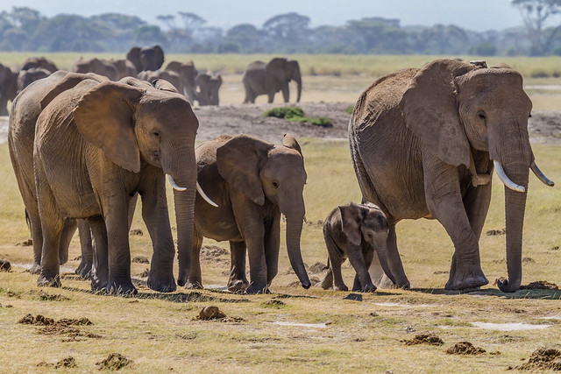

Name:___________________________________________________

Do Zoos Help or Harm Animals?
Directions
Tasks 1-8
Sixth Grade Research-Based Opinion Writing
