Name:_______________________________________

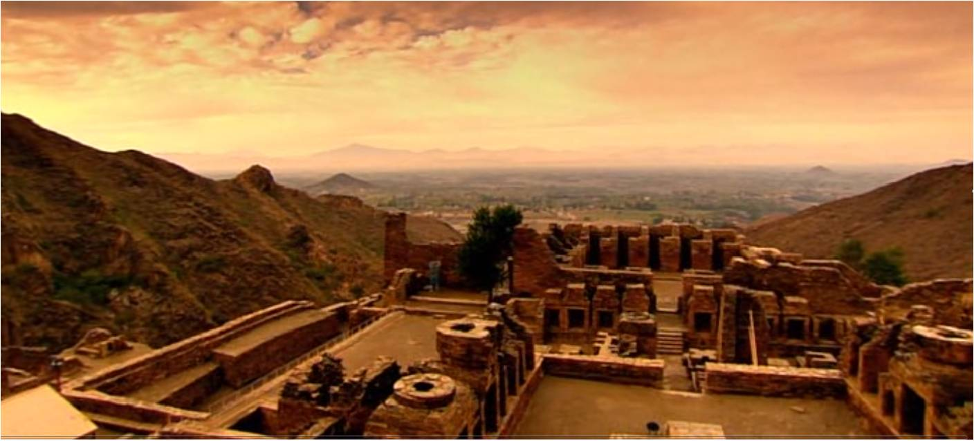
Directions:

Drawing Conclusions about the
Harappan Civilization

1) Read pages 146-148 in the social studies textbook. Pay close attention to the diagram and photos found on pages 146 and 147.

2) As you are reading, take notes and write down examples of the effects of the natural resources on Harappan civilization.

3) Also, while you are reading, take notes on the Harappan achievements.

4) While analyzing the diagram on page 146, and while analyzing the photos on page 147, make a list of the reasons that suggest that Mahenjo Daro was a well-planned city.

11) Be prepared to share your ideas with the class during Circle Time.
      - Topic to consider: Name one achievement and/or part of the Harappan society that you deem as valuable in your life. Why is this aspect of life important to you?

Natural Resources Effects
on the Harappan Society

achievement: accomplishment, success

Achievements of the Harappan civilization

*Put a star next to three of the achievements that you deem most valuable.
*Why do you believe that these achievements are most valuable?

