Name:_______________________________________
Directions:

Drawing Conclusions about the
Indian Caste System
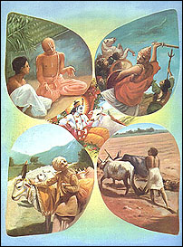

1) Read pages 149-154 in the social studies textbook. Pay close attention to the diagram found on page 153.

2) As you are reading, take notes and write down examples of the rules of the caste system in India.

3) Put a star by three rules that you think are the most harsh.

4) Be prepared to share your ideas with the class during Circle Time.
      - Topic to consider: Name one rule of the Indian caste system that you find harsh. What about this rule is harsh? Which rule would you speak out against if you lived in India?
Indian Caste System Rules

* Put a star by three rules that you think are the most harsh.

