STATE project:

State Map and Flag

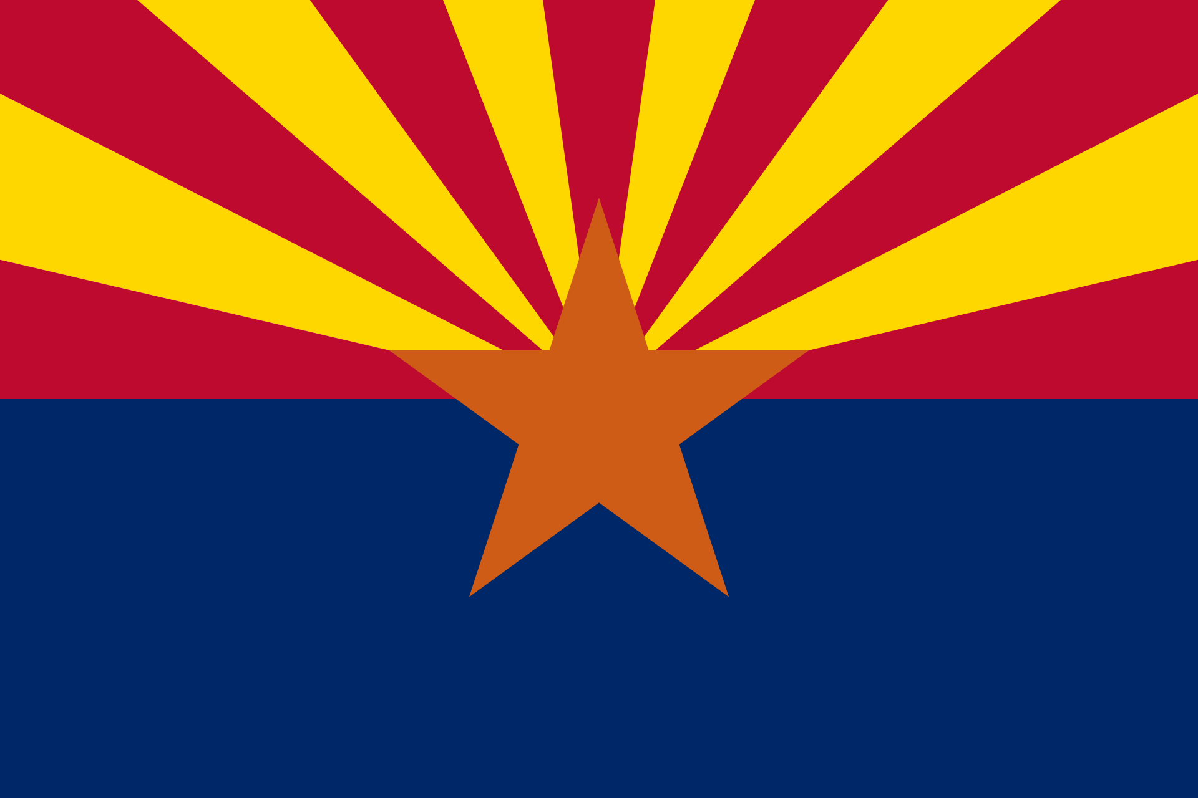

Create a flag and a map of your state:
- Step One: Using the websites provided below, or a website of your choice, draw the flag of the state you wish to visit. (The flag drawing/creation will be an extra credit grade.)
- Step Two: Using the websites provide below, or a website of your choice, draw a map of the state you wish to visit. (This map assignment is mandatory and not for extra credit.)
- Step Three: Label key cities on the state map.
- Step Four: Label key geographic features on the state map.
- Check out Mrs. Looney’s Class Website to get ideas for your map and flag of your state. http://mrslooney.weebly.com/fifth-grade-state-case-study.html Once on the webpage, scroll down to see sample drawings of maps and flags that have been created by students in the past of states that they wished to "visit."
If applicable, include the following geographic features on your state map:
  - islands
  - deserts
  - rivers
  - peninsulas
  - plateaus
  - deltas
  - mountains
  - beaches

