Country project:

Geography and Climate

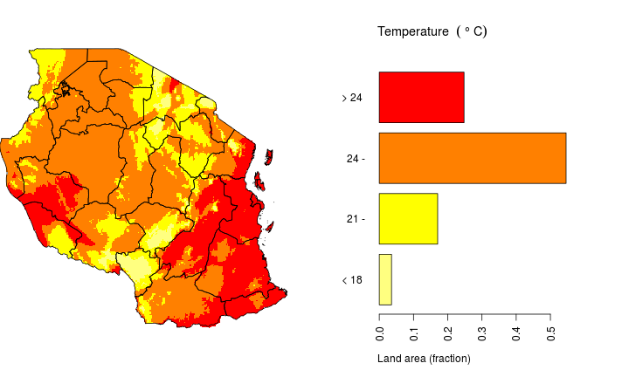

Create a Word Document, a PowerPoint, a booklet, or other project to record the information you have learned about the geography and climate of your country.
- STEP ONE: Be sure to add definitions, descriptions, illustrations, photos, and facts about the geographic features of the country you are visiting.
- STEP TWO: Be sure to include as many of the geographic features as you are able about your country on your slides of your PowerPoint, or in your paragraphs in your Word Document, or in your booklet.
Include the following features that pertain to your country:
  - islands
  - deserts
  - rivers
  - peninsulas
  - plateaus
  - deltas
  - mountains
  - volcanoes
  - oceans
  - beaches
  - marshland

- STEP THREE: Find out the climate of your country.
While using The Weather Channel website, https://weather.com/, analyze the highs and lows of the temperatures in your country. Write a paragraph or more describing the climate.

CHECKLIST:
TIPS FOR CREATING YOUR GEOGRAPHICAL FEATURES AND CLIMATE POWERPOINT (or Word Essay, or booklet, or Poster)
- Create a title page. For example:
Geographical Features and Climate of Tanzania
Created by: Lucy Loves-to-Read (write your name)
- Create a table of contents.
- On each slide, type some interesting information about each geographical feature that you discovered about your country.
- On each slide, add photos, maps, and/or graphs. Be sure to add the website (on which you found each photo) under each photo.
- Definitions: Be sure to add the definition of each geographical feature on the bottom of each slide. DO NOT COPY AND PASTE THE DEFINITION. PUT THE DEFINITION IN YOUR OWN WORDS.
- Be sure that you are using white font on a very dark background, or black font on a white or light background. Yellow font isn't usually ever a good idea.
- Be sure your font size is big enough to read well.
- DO NOT COPY AND PASTE INFORMATION FROM THE INTERNET! That is plagiarism and is illegal. Put all of the information in your own words. Use quotation marks if you are adding quotes. Please do not add more than two sentences at a time in a quote.

Number and label each slide. For example:
- Slide One: Title Page
- Slide Two: Table of Contents
- Slide Three: Geographical Map of Tanzania
- Slide Four: Mountains
- Slide Five: Rivers
- Slide Six: Lakes
- Slide Seven: Oceans
- Slide Eight: Islands
- Slide Nine: Climate and Weather
- Slide Ten: Climate Map of Tanzania
- Slide Eleven: Conclusion
***Each PowerPoint will have at least five slides. Most students will have more. Please do your best to add as any slides as you are able. Each Word Document will have at least four paragraphs with at least four sentences for each paragraph equaling 16 sentences.

