Name:_______________________________________

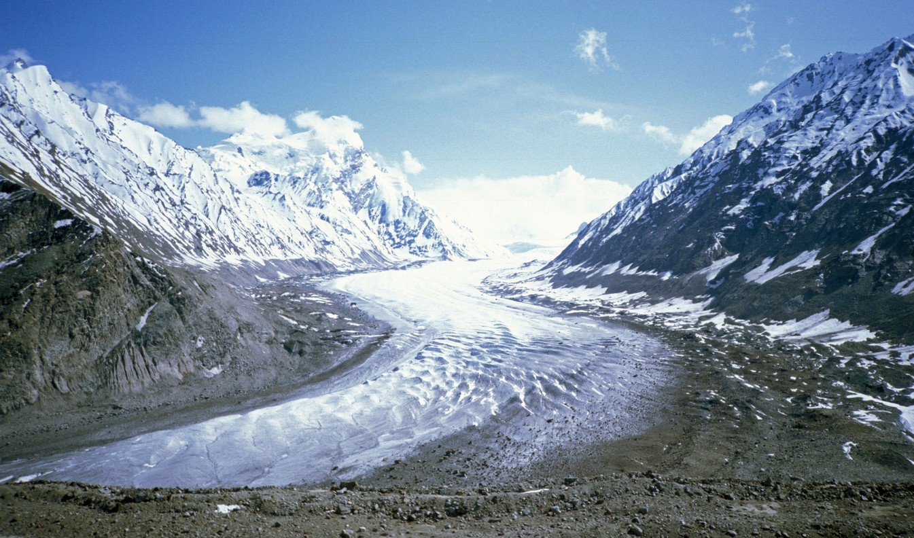
Directions:

Geography of India Cause and Effect Chart

1) Read pages 144-145 in the social studies textbook. Pay close attention to the map and monsoon patterns found on page 145.

2) As you are reading, take notes and write down examples of the causes and effects of the geography in India, specifically the causes and effects of the Himalayas and the Indus River.

3) Watch the video that shows the causes and effects of the geography in India. Take notes as you are watching. Get some ideas for your chart.

4) Devise a cause and effect chart/diagram including labels and pictures of the effects of geography in India.

5)Be sure to add a title and add your name to the front of your chart.

6) Use color.

7) Use an ultra-fine sharpie.

8) Be sure to label your chart. Use a key, if it is informative.

9) Each student should have at least three causes and three effects.

10) See Mrs. Looney’s website for student examples.

11) Be prepared to share your chart with the class during Circle Time.
      - Topic to consider: Compare the effects of Indian geography to other civilizations or places in which you are familiar.

Important Concepts-

Himalayas: highest mountains in the world
Indus river: Location of India's first civilization

Cause: something that makes another thing happen.

Effect: the result of something else that has happened.

Cause and effect: When heavy snows of the Himalayas melted, the Indus flooded which left behind a layer of silt, which created ideal farmland.

