Name: _______________________________________________

Narrative Writing:

A Hero’s Journey

6Th Grade Writing

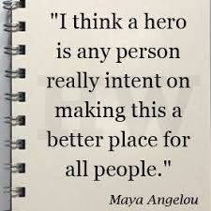

My Hero’s Journey
Questions to think about:

- Who is your character?
- What is the call to adventure?
- What is the quest? What has your hero been asked to do?
- Who does your hero go on the journey with?
- Where do they go?
- What is the new world that your hero enters?
- What obstacles do they encounter?
- What is the supreme ordeal? What is the big obstacle that they need to overcome?
- What happens at the end? How is the conflict resolved? How is peace restored?
- How does your hero get home?
- What happens once they get home?
- What elements of myth might you want to include?
- What will the theme of your story be?
Modified Hero’s Journey

This is what you will be writing about in your Hero’s Journey:

- The Ordinary World

- The Call to Adventure

- Entering the Unknown

- Supernatural Aid/Meeting the Mentor/Allies and Helpers

- Road of Trials

- Supreme Ordeal

- Ultimate Boon

- Magic Flight

Please write down your thoughts and ideas.

Modified Hero’s Journey
(Write at least ONE paragraph for each stage. I know that many of you will write more than this)

- The Ordinary World

- The Call to Adventure

- Entering the Unknown

- Supernatural Aid/Meeting the Mentor/Allies and Helpers

- Road of Trials

- Supreme Ordeal

- Ultimate Boon

- Magic Flight

