Name:_______________________________________
HINDUISM:

Essential
Vocabulary

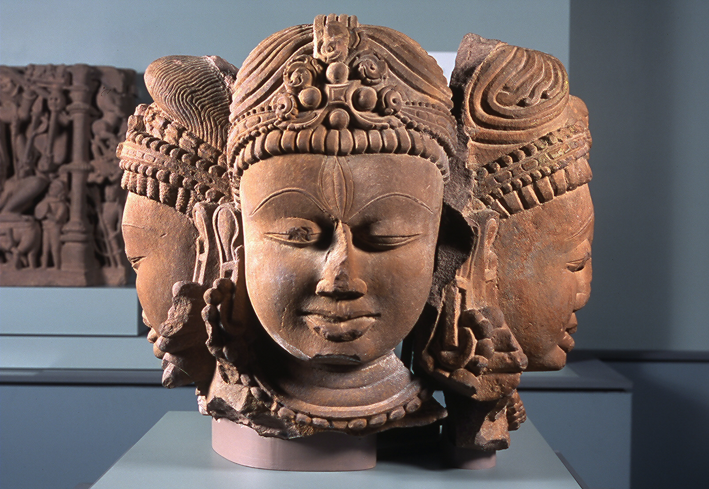

1) Read pages 155-157 in the social studies textbook. Pay close attention to the diagram found on page 156, and the list found on page 157.

2) As you are reading, take notes and write down definitions and/or descriptions of essential vocabulary about Hinduism.

3) Be prepared to share your ideas with the class during Circle Time.
      - ideas to consider: After reading the “Major Beliefs of Hinduism” found on page 157, choose one of the major beliefs of Hinduism that you can understand in your own life. Which one of the major beliefs of Hinduism do you have a hard time understanding? Why?

Hinduism: essential vocabulary

      - Hinduism: (Notice how “Hinduism” begins with a capital letter. All major religions begin with a capital letter.)

      - Brahma: (Notice how “Brahma” begins with a capital letter. The names of God in all major religions begin with a capital letter.)

      - karma:

      - Major Beliefs of Hinduism:
1)

2)

3)

4)

5)

6)

