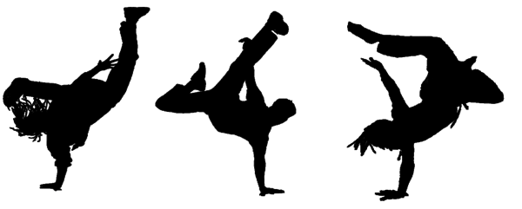
“Hip-Hop at the Museum?”
According to the author, what are some of the benefits/values of having hip-hop displays in the museum?
Use two details from the article to support your response.

Directions:
- Annotate this Directions Page.

- Read the text “Hip-Hop at the Museum?” (NOTICE HOW I PUT THE TITLE OF THE ARTICLE IN QUOTATION MARKS!)

- Annotate the article “Hip-Hop at the Museum?”
    - Use a highlighter.
    - Write at least five questions in the margins of the article.
    - Use symbols such as stars, questions marks, exclamation points, and underlines.

- In your short answer response, answer the following question:

According to the author, what are some of the benefits/values of having hip-hop displays in the museum?
Use two details from the article to support your response.
- Use the RACEEECEEER format to help you do your very best.

- Be sure to check the RACEEECEEER Rubric to make sure that your essay is of the highest caliber.

- USE THE WRITING PROMPTS AND TRANSISION WORDS FOUND IN YOUR “What does the text SAY,” “What does the author MEAN,” and “Why does it MATTER” PACKET. Students who use these transition prompts tend to score a higher grade on their writing than students who do not use these writing prompts.

- Use as many descriptive words, sophisticated vocabulary, and transition words as you can as you answer the question.

- Your short answer response will most likely be two paragraphs long.

- Write as much as you can, as quickly as you can. You will type this short answer response.

- Be sure to have someone help you proofread your essay.
- Is all of your spelling correct?
- Did you capitalize proper nouns?
- Did you capitalize beginning of sentences?
- Did you put periods, question marks, or exclamation points at the end of your sentences?
- Did you indent each new paragraph?
- Did you use interesting word choice?
- See the RACEEECEEER Rubric for more details of expectations.

