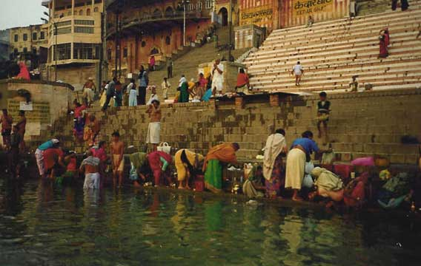
Drawing Project:

India

This Photo by Unknown Author is licensed under CC BY-NC

Draw an example of an Indian village:
- Use pages 140-176 in the social studies textbook as a guide. If you have access to the internet, use the internet as well.
- Include as many details as possible from the text, as well as from our discussions of Indian culture.
- Use color and fill up as much of the paper as possible.
- Include a title.
- Include your name.
- Label all of the details of your drawing. Add a key if you would like.
- Refer to Mrs. Looney’s Class website for ideas of drawings.

Indian Cultural Study

Include as many of the following topics as possible:
- Key geographical features

- Use of land and resources

- Daily life

- Religious beliefs

- Culture
  - Achievements
  - Art
  - Music
  - Literature
  - Architecture
  - Language
  - Clothing
  - Food

