International country project:

Introduction

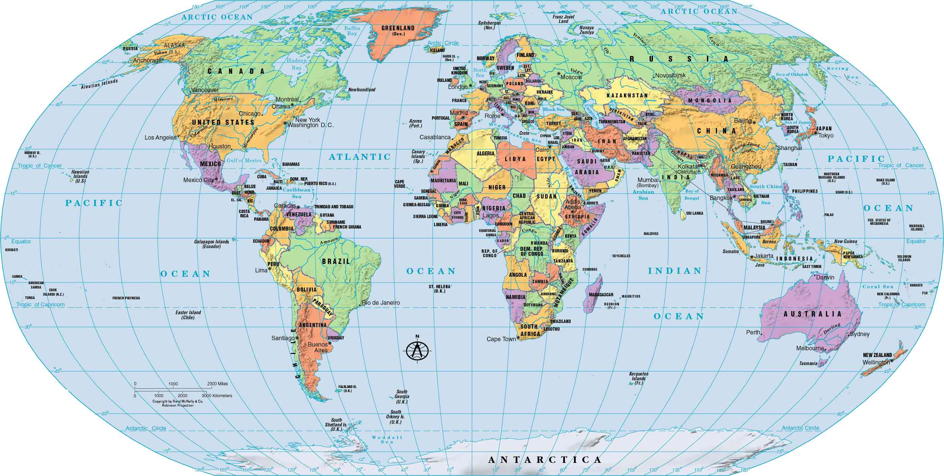

Write at least two paragraphs about the country you wish to “visit”:
- Type up a two-paragraph introduction for your country project while answering the questions below. Write at least four sentences per paragraph for a total of eight sentences. Most students will write more than four sentences per paragraph.
- The goal for this week is for students to decide on a country that they wish to "visit" and research fun facts about this country.
- Check out Mrs. Looney’s Class Website to get ideas for your country project. http://mrslooney.weebly.com/sixth-grade-international-case-study.html Students will peruse the instructions and all of the projects that are listed on this web page to get ideas of which country they wish to "visit."
- After you have decided which country you wish to “visit,” students will begin to research all about the country of choice.
While researching your country, please consider the following questions:
  - Where will you visit? What continent interests you? Africa, Europe, Asia, South America, Australia? Pick a continent and then narrow down the country you wish to “visit.”
  - What is the purpose of your adventure, the reason for your adventure? Do you want to visit cities, climb mountains, learn new languages? What is it that interests you about the country?
  - What would you like to do and see on your adventure? Where would you specifically like to visit in the country of your choice?
  - What do you hope to learn while “visiting” your country?

