Name ______________________________ Date ______________________

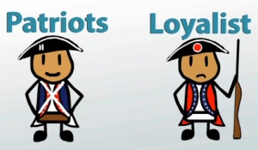
A Soldier’s
Life

Directions: Use pages 6-7 to answer the questions.

1. Define a patriot: _______________________________________________
______________________________________________________________
2. What could loyalists do? _________________________________________
______________________________________________________________
3. At what age could boys join the army?
a. 10 b. 13 c. 11 d. 14
4. Who did Native Americans side with? Why? ___________________________
______________________________________________________________
______________________________________________________________
5. What were four things that women did during the war? (Circle all that they did.)
fought in battle cooked nursed the sick
made clothes made weapons did laundry
6. What is Mary Hays, or Molly, known for? _____________________________
______________________________________________________________
7. What did some women do, like Deborah Sampson, do to be a part of the war?
______________________________________________________________
8. Describe the living conditions of a soldier. (Look at the bottom of page 7…”Both British…”)
______________________________________________________________
______________________________________________________________
9. How does reading about the living conditions of a soldier make you feel?
______________________________________________________________
______________________________________________________________
10. What is the main idea of this section? In other words, what is it mainly about?
______________________________________________________________
______________________________________________________________

