MEAL PLAN
(All friends and family invited)

Dinner:
We are going to have “deep fried brie” 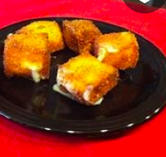

And… for and appetizer we are going to have “cheese fondue with a twist.” 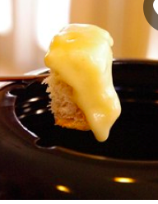

When:
Saturday May 21st
@5:00
at the hotel closest to the Eiffel tower. (Pullman Paris Tower Effiel)

Dessert:
We are going to have dessert pizza. @6:00 right after dinner. 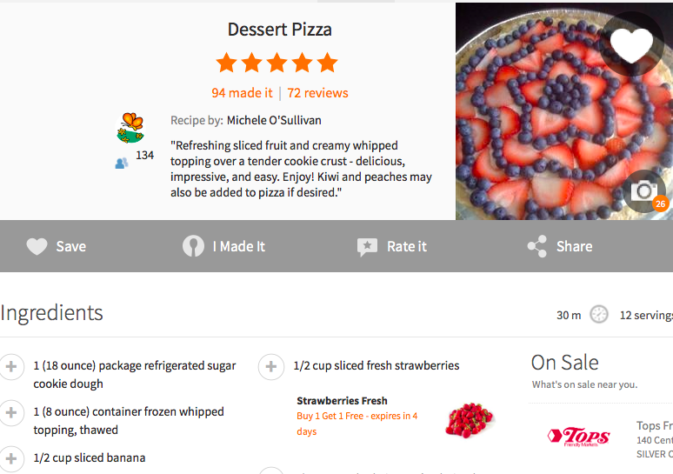

- Nice dining room.
- Eat food until 6:30 pm
- Dinner starts @5:00
- Dessert starts @6:00
- Nice steel forks on left with napkin, spoon, and knife.
- Red and gold decoration.
- Buffet with dessert plates
- Salad
- Dessert pizza
- Macaroons
- Deep fried bries
- Cheese fondu
- Dance floor
- And cake!
Hope To See You There!

