Nelson

Mandela:

Agent of change

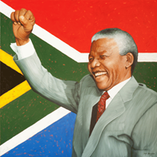

Lesson Objectives:
- Describe the lessons that Nelson Mandela can teach us.
- Rank these lessons in order of importance.
- After looking through the highlighted facts, put stars by the contributions/lessons that you find most impressive.
- In your opinion, rank the #1 and #2 lessons that can be learned by Nelson Mandela.
- Infer and describe character traits of Mandela.

Name:_____________________________________

Nelson
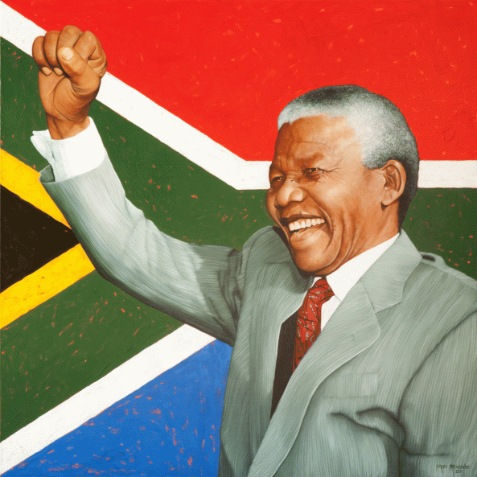

Mandela:

Agent of change

YOUTUBE VIDEO:
- U2-Ordinary Love (From Mandela OST) Lyric Video: https://youtu.be/XC3ahd6Di3M

Questions to reflect upon:
- In your opinion, what was the most important lesson/example/action that Nelson Mandela has shared with the world?
- What were some character traits of Nelson Mandela?
- Do you have any of these traits?
- In what ways could you have contributed to the people of South Africa if you lived during the time of Nelson Mandela?

Nelson Mandela
The following information was taken from the website NATIONAL GEOGRAPHIC KiDS. https://www.natgeokids.com/uk/discover/history/general-history/nelson-mandela/
Discover the remarkable life and work of Nelson Mandela – who helped change the lives of millions of South African people.
Throughout history, lots of people around the world have faced discrimination – where they are treated differently because of their race, skin color, gender, age and lots of other things, too.
Sadly, it still happens to this day! But there are some amazing people who have worked hard to make a change for better, and help us move towards a world where everyone is treated fairly and equally. One such person is Nelson Mandela…

Who was Nelson Mandela?
Full name: Nelson Rolihlahla Mandela
Born: 18 July 1918
Hometown: Mvezo, South Africa
Occupation: President of South Africa and civil rights activist
Died: 5 December 2013
Best known for: Becoming the first black President of South Africa and a civil rights hero
Also known as: Madiba

Nelson Mandela’s early life
Nelson Mandela was born on the 18th July 1918 in the village of Mvezo, in an area of South Africa called Transkei. His father’s name was Henry, and his mother’s Nosekeni Fanny.
As a youngster, little Nelson was actually called Rolihlahla – it wasn’t until he was seven that a teacher at school gave him the name ‘Nelson’, and it stuck!
And check this out… Little Nelson was born into royalty! His father, Henry, was chief of a tribe in south Africa called the Tembu, and his great grandfather was the tribe’s king! Sadly, his father died when he was just nine years old.
Nelson studied hard at school and later attended the University of Fort Hare, the South African Native College. He then moved to the city of Johannesburg to study law at the University of the Witwatersrand, before qualifying as a lawyer in 1942, aged 24.

Inequality in South Africa
South Africa is home to many different peoples and cultures – so much so that it’s been nicknamed the ‘rainbow nation’. But, sadly, at the time that Nelson Mandela was growing up, there was a huge racial divide in the country.
White people ran the country, and they generally led privileged lives with good jobs, nice homes and access to good schools and healthcare. Most black people, however, worked in low-paid jobs, and lived in poor communities with poor facilities. They had far fewer rights, too – they weren’t even allowed to vote in elections!
Like many others, Nelson Mandela felt that everyone deserved to be treated the same, regardless of their skin color.
In 1948 the South African government introduced a system called ‘apartheid’, which furthered racial divide in the country even more. Under new racist laws, black people and white people were forced to lead separate lives. They weren’t allowed to live in the same areas, share a table in a restaurant, attend the same schools or even sit together on a train or bus!

What did Nelson Mandela do?
He later travelled the country to gain support for non-violent protests against the National Party’s racists laws. But his activism made him very unpopular with the authorities, and in 1956 he was arrested for treason, the crime of betraying your country’s government. Held in Johannesburg Prison, it would be five years until the charges were dropped and Nelson was released.

Why did Nelson Mandela go to prison?
Nelson and seven other men were charged for plotting to overthrow the government and given life sentences. Nelson would spend the next 27 years behind bars. During his time behind bars, Nelson Mandela didn’t give up on what he believed in. He even refused freedom on two occasions, and instead chose to stand by his principals. He used his time to learn new things, including Afrikaans – a language of South Africa spoken mostly by white people – which earned him respect from the guards he spoke to.

When was Nelson Mandela freed from prison?
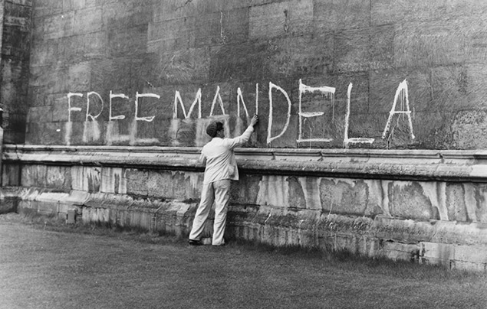
Over time, Nelson Mandela became a famous prisoner, and there were calls all around the world to ‘Free Nelson Mandela!’ For decades, countries around the world had put pressure on South Africa to end apartheid, but now the anti-apartheid movement had more support than ever. And change for the better finally came in 1989.
In 1991, Nelson became President of the ANC and worked with FR de Klerk to bring an end to apartheid in a harmonious way, and introduce equal rights for everyone. Their work towards making South Africa a more peaceful place won the pair the Nobel Peace Prize in 1993.
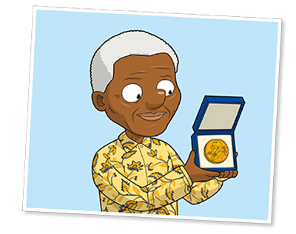
Come the 1994 general election, all races in South Africa were allowed to vote. And Nelson’s hard work for so many years finally paid off. Nelson Mandela became South Africa’s first black president.
As President of South Africa, Nelson Mandela improved the living standards and facilities of South Africa’s black population, who had suffered for decades under apartheid. He also worked hard to make South Africa a country of equality, where people of all race and color lived together in peace.

When did Nelson Mandela die?
From 2004, he lived a quiet life with his wife Graca. Following a lung infection, Nelson Mandela sadly died in December 2013, he was 95 years old.

How is Nelson Mandela remembered?
Nelson Mandela’s spirit and values are still very much alive to this day, and he will forever be remembered. He wrote a book called “Long Walk to Freedom”, where people can read about the struggles he faced in his battle against discrimination and fight for equality. In 2009, Nelson’s birthday, 18 July, was officially named ‘Nelson Mandela Day’. Every year on this day, people around the world honor his legacy by helping their communities and making the world a better place.

