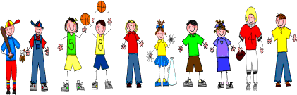

Fifth Grade
Spelling and Vocabulary Words
Unit 2, Week 3

Spelling Words: Test Friday
snore tornado
spare appear
career square
report prepare
pioneer chair
beware smear
repair sword
ignore order
engineer resort
volunteer declare

Challenge Words:
impair, directory, hardware, clearance

Vocabulary Words: Quiz Thursday

Vocabulary Word | Meaning
astonished | surprised greatly; amazed
behavior | manner of behaving; way of acting
benefactor | person who has given money or kindly help
distribution | act or process of giving some of to each; dividing and giving out in shares
gratitude | kindly feeling because of a favor received; desire to do a favor in return; thankfulness
procession | something that moves forward; persons marching or riding
recommend | to speak in favor of; suggest favorably
sacred | worthy of reverence
traditions | customs or beliefs handed down from generation to generation

