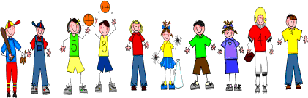
Fifth Grade
Spelling and Vocabulary Words
Unit 2, Week 4

Spelling Words: Test Friday
example level
human quarrel, scramble evil
oxygen wooden
double travel
cancel chuckle
fossil toboggan
veteran chisel
suburban single
sudden beagle
Challenge Words: obstacle, kindergarten, abdomen, enlighten
Vocabulary Words: Quiz Thursday

Vocabulary Word | Meaning
conservation | preservation from harm or decay; protection from loss or from being used up
contribute | to help bring about
enthusiastic | eagerly interested
environment | condition of the air, water, soil, etc.
investigation | a careful search

