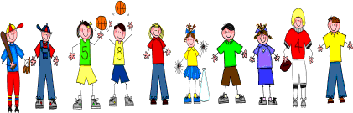

Fifth Grade
Spelling and Vocabulary Words
Unit 2, Week 5

Spelling Words: Test Friday
danger wander
tractor dollar
harbor eager
eraser surrender
solar sticker
locker helicopter
pillar refrigerator
caterpillar rumor
glimmer linger
sensor alligator
Challenge Words: numerator, collector, ancestor, counselor
Vocabulary Words: Quiz Thursday

Vocabulary Word | Meaning
fate | what becomes of someone or something
fearless | without fear; afraid of nothing
glimmer | a faint, unsteady light
lingers | stays on; goes slowly, as if unwilling to leave
magnified | caused something to look larger than it actually is
somber | having deep shadows; dark; gloomy
steed | a horse; especially a riding horse

