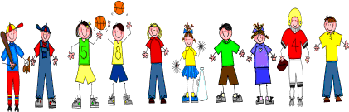
Fifth Grade
Spelling and Vocabulary Words
Unit 3, Week 1

Spelling Words: Test Friday
jewel kingdom gasoline factory
garage tropical
pajamas estimate
tomorrow humidity Chicago bulletin
carnival illustrate
elegant census
terrific celebrate
operate celery
Challenge Words:
rehearsal, salamander, prominent, significant, parakeet

Vocabulary Words: Quiz Thursday

Vocabulary Word | Meaning
admiringly | with wonder, pleasure, and approval
permit | to let; allow
scoundrel | an evil, dishonorable person
subject | person under the power, control, or influence of another
worthless | without value; good-for-nothing; useless

