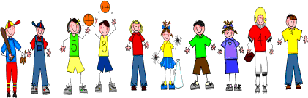
Fifth Grade
Spelling and Vocabulary Words
Unit 3, Week 5

Spelling Words: Test Friday
uncover defrost uncomfortable discourage disadvantage unfortunate unfamiliar disability discomfort deodorant unemployed deflate
disbelief unpredictable disapprove disappoint unpleasant dehydrated disqualify undecided
Challenge Words:
unnecessary, disobedient, dehumidifier, disinfectant, disenchanted

Vocabulary Words: Quiz Thursday

Vocabulary Word | Meaning
background | the part of a picture or scene toward the back
landscape | a view of scenery on land
miniature | reduced image or likeness; done on a small scale
prehistoric | belonging to periods before recorded history
reassembled | came, brought, or put together again

