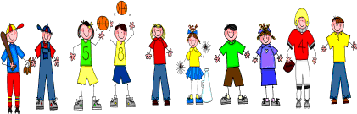
Fifth Grade
Spelling and Vocabulary Words
Unit 4, Week 1

Spelling Words: Test Friday
khaki hula
banana waltz
tomato vanilla
canyon yogurt
banquet macaroni
polka cobra
koala barbecue
safari buffet
stampede karate
kiosk papaya
Challenge Words:
artichoke, sauerkraut, succotash, tsunami
Vocabulary Words: Test Friday

Vocabulary Word | Meaning
blunders | stupid mistakes
civilization | the ways of living or a people or nation
complex | made up of a number of parts; hard to understand
envy | feeling of discontent, dislike, or desire because another person has what you want
fleeing | running away
inspired | filled with a thought or feeling; influenced
rustling | causing a light, soft sound of things gently rubbing together
strategy | the skillful planning and management of anything

