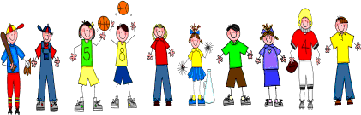
Fifth Grade
Spelling and Vocabulary Words
Unit 4, Week 2

Spelling Words: Test Friday
overlook underline subway subset supermarket outlet underground overboard undercurrent superstar overtime supersonic submarine undercover overcast outfield
output supernatural subdivision subhead
Challenge Words:
overwhelm, underestimate, underprivileged, subcommittee
Vocabulary Words: Quiz Thursday

Vocabulary Word | Meaning
abdomen | the part of the body containing the stomach, intestines, and other important organs
artificial | made by human skill or labor; not natural
gait | a manner of walking or running
handicapped | having a physical or mental disability
therapist | a person who specializes in treatment of diseases, injuries, or disorders
wheelchair | a chair on wheels, used by people who are sick or who are unable to walk

