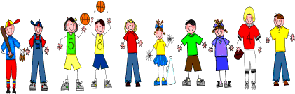
Fifth Grade
Spelling and Vocabulary Words
Unit 4, Week 3

Spelling Words: Test Friday
cent sent
scent threw
through weather
whether their
there they’re
chili chilly
tide tied
pale pail
aloud allowed
course coarse
Challenge Words:
counsel, council, bizarre, bazaar, patients, patience
Vocabulary Words: Quiz Thursday

Vocabulary Word | Meaning
critical | being important to the outcome of a situation
enables | gives ability, power, or means to: makes able
mucus | a slimy substance produced in the nose and throat to moisten and protect them
scarce | hard to get; rare
specialize | to develop in a special way
sterile | free from germs

