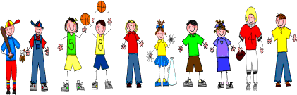
Fifth Grade
Spelling and Vocabulary Words
Unit 4, Week 4

Spelling Words: Test Friday
sensible washable available agreeable fashionable valuable
flexible reasonable favorable breakable convertible forgettable laughable sociable allowable divisible hospitable reversible responsible tolerable
Challenge Words:
noticeable, conceivable, disposable, biodegradable, collapsible

Vocabulary Words: Quiz Thursday

Vocabulary Word | Meaning
cavities | hollow places; holes in teeth caused by decay
combination | a series of numbers or letters dialed in opening a certain kind of lock
demonstrates | shows how a thing is done
episode | one part of a story that is published or broadcast in several parts, one at a time
profile | low profile, moderate attitude or position, deliberately chosen in order to avoid notice
strict | very careful in following a rule or making other follow it

