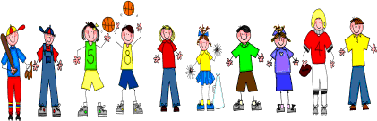
Fifth Grade
Spelling and Vocabulary Words
Unit 5, Week 1

Spelling Words: Test Friday elementary vehicle
miniature probability definition substitute
variety literature elevator Pennsylvania ravioli cafeteria
mosaic tuxedo
meteorite fascination cylinder intermediate centennial curiosity
Challenge Words:
documentary, stegosaurus, pediatrician, mediocre, simultaneous

Vocabulary Words: Quiz Friday

Vocabulary Word | Meaning
eerie | causing fear because of strangeness or weirdness
intersection | point, line, or place where one thing crosses another
pondered | considered carefully; thought over
severe | serious; grave
spectacles | eyeglasses
withered | lost or caused to lose freshness; made or became dry and lifeless

