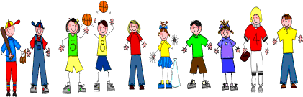
Fifth Grade
Spelling and Vocabulary Words
Unit 5, Week 2

Spelling Words: Test Friday
league sergeant
yacht doubt
fatigue debt
blood vague
anxious foreign
bargain condemn intrigue villain cantaloupe flood
depot cordial
subtle disguise
Challenge Words:
bureau, reminiscent, adjective, monologue, environment
Vocabulary Words: Quiz Thursday

Vocabulary Word | Meaning
cramped | shut into a small space
debris | scattered fragments; ruins; rubbish
interior | inner surface or part; inside
ooze | a soft mud or slime, especially at the bottom of a pond or river or on the ocean bottom
robotic | of or for a machine with moving parts and sensing devices controlled by a computer
sediment | material that settles to the bottom of a liquid
sonar | device for finding the depth of water or for detecting and locating underwater objects

