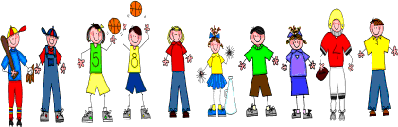
Fifth Grade
Spelling and Vocabulary Words
Unit 5, Week 3

Spelling Words: Test Friday
geology thermometer astronaut atmosphere biology thermal
disaster meteorology technology hemisphere zoology sociology biosphere thermos
asterisk thermostat astronomy spherical ecology mythology
Challenge Words: psychology, anthropology, thermoelectric, astronomical, microbiology

Vocabulary Words: Quiz Thursday

Vocabulary Word | Meaning
accomplished | things that have been done with knowledge, skill, or ability; achievements
focus | the central point of attraction, attention, or activity
gravity | the natural force that causes objects to move or tend to move toward the center of the earth
monitors | screens connected to a computer, which show information and instructions
role | a part played by a person in real life; role model, person whose patterns of behavior influence someone else’s actions and beliefs
specific | definite; precise; particular

