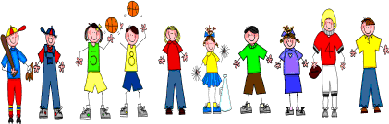
Fifth Grade
Spelling and Vocabulary Words
Unit 5, Week 4

Spelling Words: Test Friday
project audience
decade territory auditorium terrier
decimal injection December reject
eject terrace
audit decimeter audition audible decathlon terrarium dejected terrain
Challenge Words:
terra cotta, subterranean, conjecture, trajectory, terrestrial

Vocabulary Words: Quiz Thursday

Vocabulary Word | Meaning
armor | any kind of protective covering
encases | covers completely; encloses
extinct | no longer existing
hideous | very ugly; frightful; horrible
plunged | fell or moved suddenly downward or forward
serpent | snake, especially a big snake

