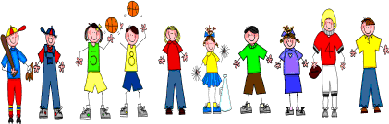
Fifth Grade
Spelling and Vocabulary Words
Unit 5, Week 5

Spelling Words: Test Friday
politics political
major majority
equal equation
sign signature
arrive arrival
inspire inspiration human humanity
clean cleanse
resign resignation
unite unity
Challenge Words
magic, magician, remedy, remedial,
individual, individuality

Vocabulary Words: Test Thursday

Vocabulary Word | Meaning
economic | of or about the management of the income, supplies, and expenses of a household, government, etc.
independence | freedom from the control, influence, support, or help of others
overrun | to spread over
scrawled | written or drawn poorly or carelessly
vacant | not occupied

