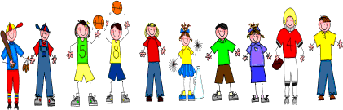

Sixth Grade
Spelling and Vocabulary Words
Unit 2, Week 4

Spelling Words: Test Friday
different instance
sentence communicate
American hesitate
brilliant elementary
substitute vitamin
opinion ingredients
material invitation
complete discipline
jewelry lasagna
dramatic desperate
Challenge Words:
ferocious, orangutan, sympathetic
Vocabulary Words: Quiz Thursday

Vocabulary Word | Meaning
combustion | act or process of burning
dingy | lacking brightness or freshness; dirty-looking
negotiate | to talk over and arrange terms
traversed | passed across, over, or through
waft | a breath or puff of air, wind, scent
waning | going through its regular reduction in the amount of its visible portion, such as the moon

