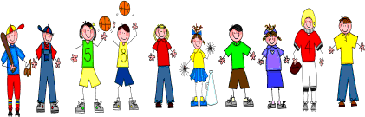

Sixth Grade
Spelling and Vocabulary Words
Unit 3, Week 4

Spelling Words: Test Friday
field trip lightning rod
someone myself
snowflakes life jacket
polka dot bulldozer
roller coaster masterpiece
solar system area code
thunderstorm cliffhanger
leftovers wheelchair
cell phone hour hand
whitewash rain forest
Challenge Words: graham cracker, rhinestone, racquetball
Vocabulary Words: Quiz Thursday

Vocabulary Word | Meaning
confidently | certainly; surely; with firm belief
dismounted | got off something, such as a horse or bicycle
distressed | in great pain or sorrow
flourish | to grow or develop will; thrive
fulfill | to perform or carry out a duty or command
permission | consent
repay | to do or give something in return for something received
vigorously | strongly; actively; energetically

