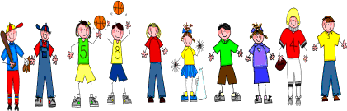

Sixth Grade
Spelling and Vocabulary Words
Unit 3, Week 5

Spelling Words: Test Friday
heel straight
heal strait
symbol aisle
cymbal isle
heard stationery
herd stationary
patients sheer
patience shear
capitol bread
capital bred
Challenge Words:
discreet, discrete, adolesence
Vocabulary Words: Quiz Thursday

Vocabulary Word | Meaning
absurd | plainly not true; ridiculous
behalf | side, interest, or favor
candidate | person who seeks some position
dean | head of a division or school in a college or university
delirious | wildly excited

