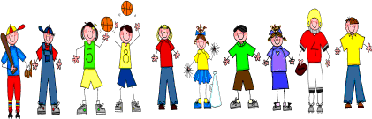

Sixth Grade
Spelling and Vocabulary Words
Unit 4, Week 3

Spelling Words: Test Friday
precious potion
commercial digestion
especially artificial
ancient glacier
gracious cautious
position efficient
question sensational
suggestion vicious
friction official
lotion ration
Challenge Words:
fictitious, beneficial, emancipation
Vocabulary Words: Quiz Thursday

Vocabulary Word | Meaning
bondage | being held against your will under the control of another; slavery
commissioned | holding the rank of second lieutenant or above in the U.S. army
earthen | made of ground, soil, or earth
encounter | meet unexpectedly; meet in a battle
primitive | very simple
sanctuaries | places or refuge or protection
stimulating | lively; engaging

