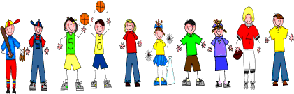

Sixth Grade
Spelling and Vocabulary Words
Unit 4, Week 4

Spelling Words: Test Friday
poem poetic
direct direction
origin original
combine combination repeat repetition
critic criticize
history historic
academy academic
inspire inspiration depart departure
Challenge Words: erode, erosion, confiscate, confiscation
Vocabulary Words: Quiz Thursday

Vocabulary Word | Meaning
aliens | imaginary creatures from outer space
barge | a large, strongly-built boat or ship for carrying freight or waste
hospitable | friendly; receptive
molten | made liquid by heat
ore | rock containing enough of a metal or metals to make mining profitable
refrain | to keep yourself from doing something
universal | existing everywhere
version | a special form or variant of something

