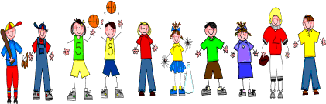

Sixth Grade
Spelling and Vocabulary Words
Unit 4, Week 5

Spelling Words: Test Friday
electricity equality
society specialty celebrity recognition description reduction tradition loyalty
security clarity
popularity certainty
cruelty subscription reputation intention deception penalty
Challenge Words: pronunciation, hospitality, demonstration, subtlety

Vocabulary Words: Quiz Thursday

Vocabulary Word | Meaning
converts | changes
devise | invent
efficiency | ability to produce the effect wanted without waste of time or energy
generated | produced
percentage | allowance figured by percent
proclaimed | declared publically
reproduce | to make a copy of
transmitted | sent out signals by means of electromagnetic waves or by wire

