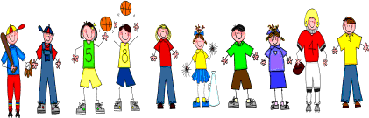

Sixth Grade
Spelling and Vocabulary Words
Unit 6, Week 1

Spelling Words: Test Friday
bakery scenery
vocabulary temporary
surgery inventory
directory pottery
discovery imaginary
machinery nursery
voluntary honorary
satisfactory introductory
advisory bribery
secondary bravery
Challenge Words: itinerary, accessory, inflammatory, anniversary
Vocabulary Words: Quiz Thursday

Vocabulary Word | Meaning
lance | a long, wooden spear with a sharp iron or steel head
misfortune | bad luck
quests | expeditions by knights in search of something
renewed | to have been made like new; restored
renowned | famous
resound | to echo
squire | attendant

