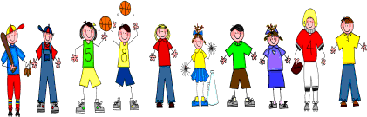

Sixth Grade
Spelling and Vocabulary Words
Unit 6, Week 2

Spelling Words: Test Friday
alternative alternate
office official
economy economics
normal normality
restore restoration
indicate indicative
gene genetic
excel excellence
adapt adaptation
crime criminal
Challenge Words: contaminate, contamination, initiate, initiative
Vocabulary Words: Quiz Thursday

Vocabulary Word | Meaning
architecture | style or special manner of building
democracy | government that is run by the people who live under it
empire | a group of countries or states under one rule or government
ideal | just as you would wish; perfect
mythology | a group of legends or stories about a particular country or person

