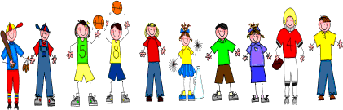

Sixth Grade
Spelling and Vocabulary Words
Unit 6, Week 3

Spelling Words: Test Friday
proceed precede
advise advice
formerly formally
further farther
personal personnel
immigrate emigrate
college collage
descent dissent
persecution prosecution
envelope envelop
Challenge Words: eminent, imminent, liable, libel
Vocabulary Words: Quiz Thursday

Vocabulary Word | Meaning
disgraced | to have caused a loss of honor or respect
progress | an advance or growth; development; improvement
promoted | raised in rank; condition of importance
relish | a side dish to add flavor to food
retreat | the act of withdrawing
revolting | disgusting; repulsive
unison | together; as one

