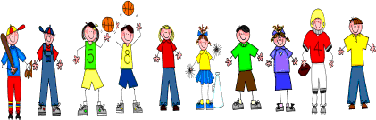

Sixth Grade
Spelling and Vocabulary Words
Unit 6, Week 5

Spelling Words: Test Friday
vision suspect
visible donate
spectator visor
current excursion
revise pardon
prospective provision
supervisor inspector
spectacle concur
recur visitor
donor donation
Challenge Words: spectacular, visionary, visibility, occurrence
Vocabulary Words: Quiz Thursday

Vocabulary Word | Meaning
burden | something carried; load of things, care, work, or duty
confirmed | were the same as; agreed
leisure | free; not busy
maintenance | act of keeping in good repair
rural | in the country
sufficient | enough
urban | typical of cities

